Evaluation of the Design and Construction of the Tailings Dams for the Mirador Mine, Zamora Chinchipe, Ecuador

Steven H. Emerman, Malach Consulting, 785 N 200 W, Spanish Fork, Utah 84660, USA, E-mail: SHEmerman@gmail.com, Tel: 1-801-921-1228

Report written at the request of E-Tech International
Spanish version submitted on February 19, 2019
Spanish version revised on February 26, 2019
English translation submitted on October 15, 2019

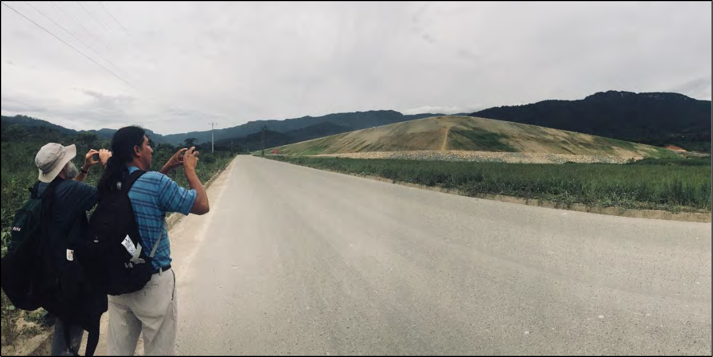
Figure 1. The author (on the left) and Luis Sanchez Zhiminaycela (activist with Comunidad Amazónica de Acción Social Cordillera del Cóndor Mirador) study the starter dike of the Quimi tailings dam at the Mirador mine. Photo taken by Evelyne Blondeel on November 6, 2018.

LIGHTNING SUMMARY

An earlier design of the tailings dam for the Mirador mine, Zamora Chinchipe, Ecuador, included a height of 63 meters, an outer embankment slope of 1V:2H, centerline construction, and the ability to withstand the Probable Maximum Flood. A stability analysis determined that the tailings and the foundation would liquefy during the earthquake that is expected to occur during the life of the project. The tailings dam currently under construction includes an outer embankment slope of 1V:1H, upstream construction (more susceptible to failure due to both seismic liquefaction and overtopping), the ability to withstand only a 500-year flood, and a projected height of 260 meters (the tallest ever constructed). Failure due to earthquakes, overtopping or internal erosion is inevitable. An immediate moratorium on the further construction of the Mirador mine is recommended, followed by the convening of an independent panel of international experts for the evaluation of the Mirador tailings management facilities.

TABLE OF CONTENTS

ABSTRACT | 3
OVERVIEW | 3
REVIEW OF TAILINGS DAMS | 4
Tailings Dams and Water-Retention Dams | 4
Methods of Construction of Tailings Dams | 7
Causes of Failure of Tailings Dams | 10
Methods of Construction and Causes of Failure | 12
Safety Criteria for the Design of Tailings Dams | 14
DESIGN OF THE TAILINGS MANAGEMENT FACILITY AT THE MIRADOR  MINE | 16
Earlier Version and its Critiques | 16
Final Version and its Critiques | 19
METHODOLOGY | 23
RESULTS | 24
Safety Criteria for Floods and Earthquakes | 24
Use of Non-Sulfidic Tailings for the Construction of the Tailings Dams | 25
Additional Risks of Failure of the Tailings Dams | 25
Contradictions between Construction and Design | 26
DISCUSSION | 30
Explanation for the Contradictions between Construction and Design | 30
Probability of Failure of the Mirador Tailings Dams | 32
Consequences of Failure of the Tailings Dams | 33
CONCLUSIONS | 34
RECOMENDATIONS | 35
ACKNOWLEDGEMENTS | 35
ABOUT THE AUTHOR | 35
REFERENCES | 35

ABSTRACT

An earlier design of the dam for the Quimi tailings management facility at the Mirador copper mine, Zamora Chinchipe, Ecuador, included a height of 63 meters, an outer embankment slope of 1V:2H (vertical to horizontal ratio), centerline construction, and the ability to withstand the Probable Maximum Flood (significantly rarer than even a 10,000-year flood). A stability analysis carried out by consultants hired by the mining company (EcuaCorriente S.A.) determined that the total depth of the tailings, as well as the foundation, would liquefy during the earthquake that is expected to occur during the life of the project. An independent evaluation critiqued the excessive amount of water that would be stored with the tailings and the lack of a geosynthetic liner to prevent contamination of groundwater. The subsequent Environmental Impact Study (EIS) included two alternatives for the expansion of the proposed production from
30,000 metric tons per day to 60,000 metric tons per day: a Quimi tailings management facility (the earlier design with dewatering of tailings) or a Tundayme tailings management facility (preferred by the mining company) with a height of 260 meters (the tallest ever constructed), an outer embankment slope of 1V:1.5H, centerline construction, and the ability to withstand only a
500-year flood. Both alternatives included the use of non-sulfidic tailings (non-acid generating) for the construction of the dams with no error bounds in the estimation of the available amount of non-sulfidic tailings and no plan as to what to do if there are not enough non-sulfidic tailings. In contradiction with the EIS, both alternatives (Quimi and Tundayme tailings management facilities) are currently under construction, although currently only the Quimi facility has the starter dike for the dam. The location of the starter dike requires the upstream construction method (more susceptible to failure due to both seismic liquefaction and flooding) and has an outer embankment slope of 1V:1H (considered as the maximum critical angle for the prevention of internal erosion with no margin for error). The provincial government has denounced EcuaCorriente for quarrying river rocks for construction material in violation of permits, which
suggests that there is a lack of material for the proper construction of the dams. Based on the above, the failure of any of the tailings dams due to earthquakes, overtopping or internal erosion should be regarded as inevitable. An immediate moratorium on further construction of the Mirador mine is recommended, followed by the convening of an independent panel of international experts for the evaluation of the Mirador tailings management facilities.

OVERVIEW

The Chinese-owned mining company EcuaCorriente S.A. is currently constructing the Mirador mine in the province of Zamora Chinchipe, Ecuador (see Figs. 1 and 2). At full production, this mine will process 60,000 metric tons of ore per day for 30 years to produce copper, gold and silver concentrates. Since the vast majority of the ore is not copper, gold or silver, after crushing and floating the ore, the processing of the ore will result in almost 60,000 metric tons per day of waste, which are called mine tailings or simply tailings. Tailings are toxic due to the toxic elements that tend to be associated with ore bodies, as well as their ability to produce acid mine drainage. These tailings will be confined within two tailings management facilities that are under construction. These facilities include dams that prevent the release of tailings to the environment and soil liners that prevent contamination of groundwater by the confined tailings. The purpose of this report is to answer the following question: Is the design and construction of the tailings dams consistent with widely-recognized safety guidelines?

Before addressing this question, I will review the methods of tailings dam construction, the common causes of tailings dam failures, and the methods for preventing the failure of tailings dams. Much of this information is available in the standard textbook on tailings dams by Vick (1990). This report analyzes only the prevention of dam failures based on the construction of the dam and other aspects of the tailings management facility. Methods to prevent failure by altering the nature of tailings, such as the conversion of tailings into a paste, are analyzed elsewhere (Klohn Crippen Berger, 2017).

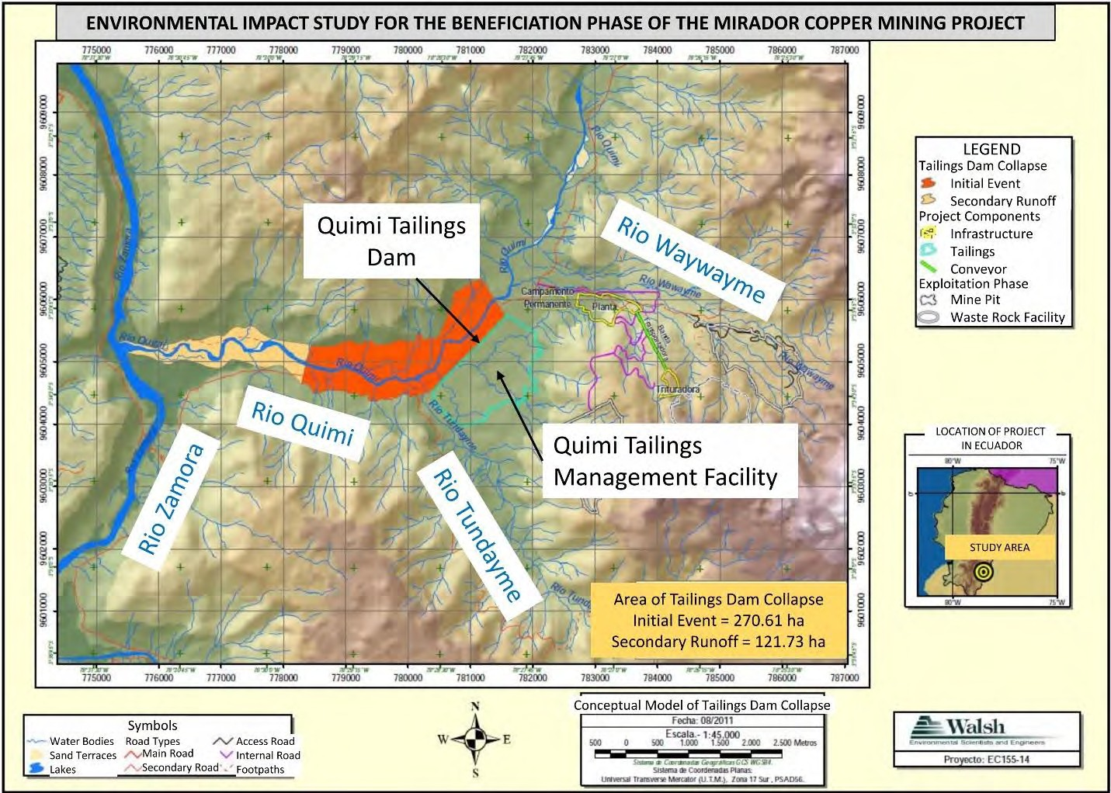
Figure 2. The Mirador copper mine is currently under construction by EcuaCorriente S.A. in Zamora Chinchipe, Ecuador. An earlier Environmental Impact Study (EIS) in 2010 proposed a single tailings management facility (called the Quimi tailings management facility) and calculated the extent of the tailings spill after failure of the dam. The extent of the initial event (orange) was calculated using a formula that has been shown to be incorrect. The extent of secondary runoff was not based on any calculation, but was simply a drawing. In fact, the spilled tailings will be transported by the Rio Zamora to the headwaters of the Amazon River. Figure modified from Walsh Scientists and Engineers (2011b).

REVIEW OF TAILINGS DAMS

Tailings Dams and Water-Retention Dams

Although tailings dams and water-retention dams are built for the purpose of restricting the flow of material, they are fundamentally different types of civil engineering structures. This important point was emphasized by Vick (1990), “A recurring theme throughout the book is that

there are significant differences between tailings embankment and water-retention dams…Unlike dams constructed by government agencies for water-retention purposes, tailings dams are subject to rigid economic constraints defined in the context of the mining project as a whole. While
water-retention dams produce economic benefits that presumably outweigh their cost, tailings dams are economic liabilities to the mining operation from start to finish. As a result, it is not often economically feasible to go to the lengths sometimes taken to obtain fill for conventional water dams.” Vick (1990) gave an example of how a tailings dam could be built in the same way as a water-retention dam, although he emphasized the economic unfeasibility of such construction (see Fig. 3). (The importance of the features in Fig. 3, such as the impermeable
core, the filter and the drainage zone, will be discussed later.)

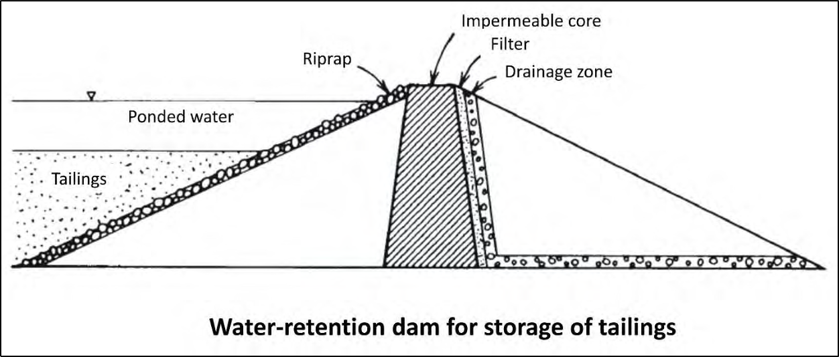
Figure 3. Tailings dams and earthen water-retention dams are fundamentally different civil engineering structures. Vick (1990) showed how a tailings dam could be constructed in the same way as a water-retention dam and that it would be as safe as a typical water-retention dam. The design includes an impermeable core and a drainage zone to lower the water table at the toe of the dam, and a filter to prevent internal erosion (transport of solid particles out of the dam by seepage). However, the design would not be economically feasible for a tailings dam. Figure modified from Vick (1990).

In addition to the economic unfeasibility of traveling the distances that are sometimes ideal for obtaining appropriate fill, Vick (1990) gives many other examples of ways in which it is not economically feasible to build a tailings dam in the same way as a water-retention dam. An earthen water-retention dam is constructed out of rock and soil that is chosen for its suitability
for the construction of dams. However, a tailings dam is normally built out of construction material that is created by the mining operation, such as the waste rock that is removed before reaching the ore, or the mine tailings themselves after proper compaction. In addition, a water- retention dam is built completely from the beginning before its reservoir is filled with water, while a tailings dam is built in stages as more tailings are produced that require storage and as material from the mining operation (such as waste rock) becomes available for construction. Finally, at the end of its useful life, or when it is no longer possible to inspect and maintain the dam, a water-retention dam is completely dismantled. On the other hand, a tailings dam is expected to confine the toxic tailings in perpetuity, although normally the inspection and maintenance of the dam cease after the end of the mining project.

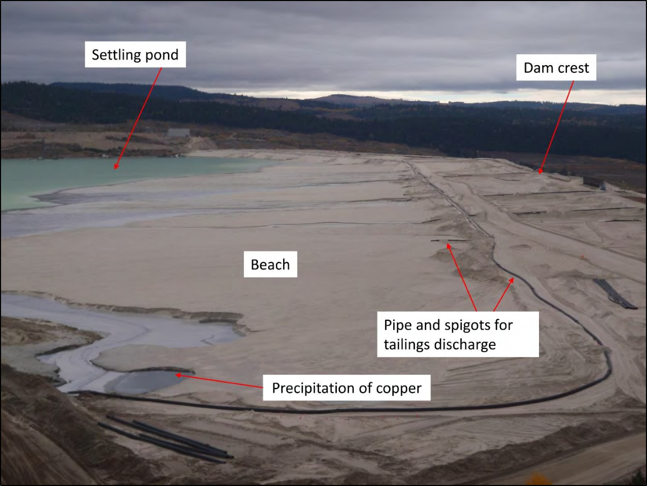
Figure 4. At the tailings storage facility of the Highland Valley Copper mine in British Columbia, wet tailings are discharged in the upstream direction from a pipe and spigots along the crest of the dam. The larger particles (sands) are deposited near the dam to form a beach. The smaller particles (slimes) are transported farther from the dam to form a settling pond. The precipitation of copper in the tailings pond indicates the incomplete extraction of copper from the ore. The narrow beach (especially on the opposite side, where the beach is almost non-existent) makes the dam susceptible to failure by overtopping. Photo taken by the author on September 27, 2018.

The consequences of the very different constructions of tailings dams and water-retention dams are the very different safety records of the two types of structures. According to a widely- cited paper by Davies (2002), “It can be concluded that for the past 30 years, there have been approximately 2 to 5 ‘major’ tailings dam failure incidents per year… If one assumes a worldwide inventory of 3500 tailings dams, then 2 to 5 failures per year equates to an annual probability somewhere between 1 in 700 to 1 in 1750. This rate of failure does not offer a favorable comparison with the less than 1 in 10,000 that appears representative for conventional dams. The comparison is even more unfavorable if less ‘spectacular’ tailings dam failures are considered. Furthermore, these failure statistics are for physical failures alone. Tailings impoundments can have environmental ‘failure’ while maintaining sufficient structural integrity (e.g. impacts to surface and ground waters).” Both the total number of tailings dams and the number of tailings dams failures cited by Davies (2002) are probably too low (World Mine Tailings Failures, 2018). However, the Independent Expert Engineering Investigation and
Review Panel (2015) found a similar failure rate in tailings dams of 1 in 600 per year during the

1969-2015 period in British Columbia. (See World Mine Tailings Failures (2018) for the most up-to-date information on mine tailings failures.)

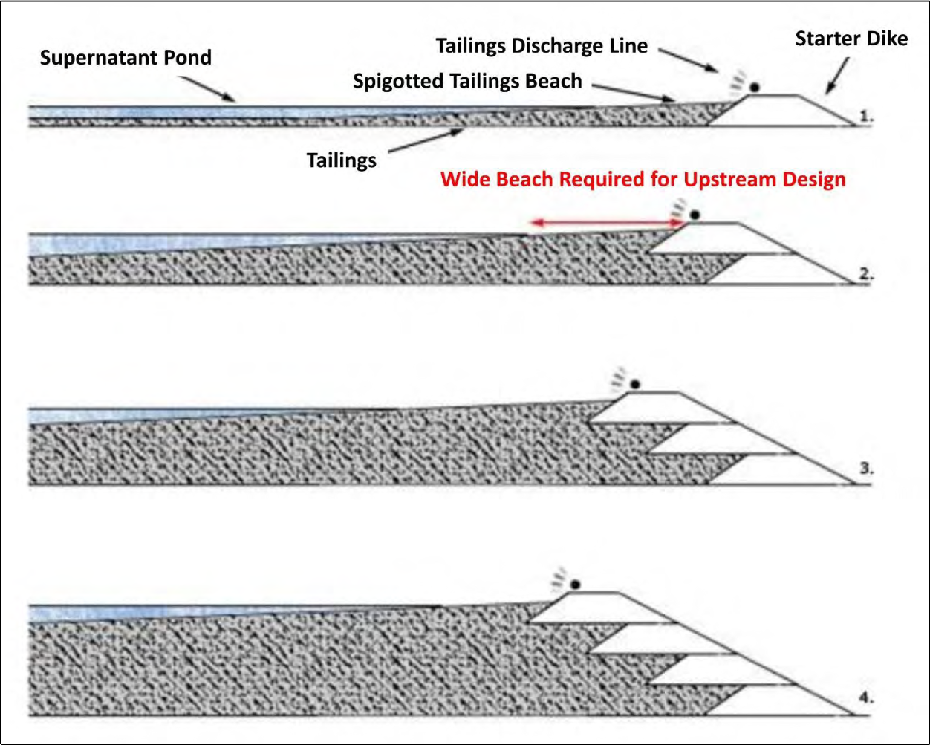
Figure 5a. In the upstream construction method, successive dikes are built in the upstream direction as the level of stored tailings increases. The dikes can be constructed out of mining waste rock, natural soil or the coarser fraction of tailings (with appropriate compaction). The advantage of the method is its low cost since very little material is required for the construction of the dam. The disadvantage is that the dam is susceptible to failure by seismic liquefaction since the wet uncompacted tailings are underneath the dam. For this reason, the upstream construction method is illegal in some countries with seismic activity, such as Chile. Dams built by this method are also likely to fail by overtopping when the beach is too narrow due to insufficient sand in the discharged tailings or excessive water in the settling pond. Figure modified from TailPro Consulting (2018).

Methods of Construction of Tailings Dams

All methods of construction of tailings dams are means of taking advantage of the very different physical properties of the two sizes of tailings, which are the sands (larger than 0.075 mm) and the slimes (smaller than 0.075 mm). These two sizes are separated by gravity in tailings management facilities. Normally, a mixture of tailings and water is discharged into the tailings pond from the crest of the dam through spigots that connect to a pipe that comes from the ore processing plant (see Fig. 4). The larger sands settle closer to the dam to form a beach. The smaller slimes and water travel farther from the dam to form a settling pond where the slimes

slowly settle out of suspension. It should be noted that the beach is essential for preventing the pond from reaching the crest of the dam.
Each of the three common methods of building tailings dams (upstream, downstream and centerline) begins with a starter dike, which is constructed from natural soil, waste rock or the tailings from an earlier episode of ore processing (see Figs. 5a-c). In the upstream construction method, successive dikes are built in the upstream direction as the level of stored tailings increases. As mentioned earlier, it is most common to build successive dikes from waste rock or the coarser fraction of tailings (with appropriate compaction). The advantage of the method is its low cost since very little material is required for the construction of the dam (see Fig. 5a).

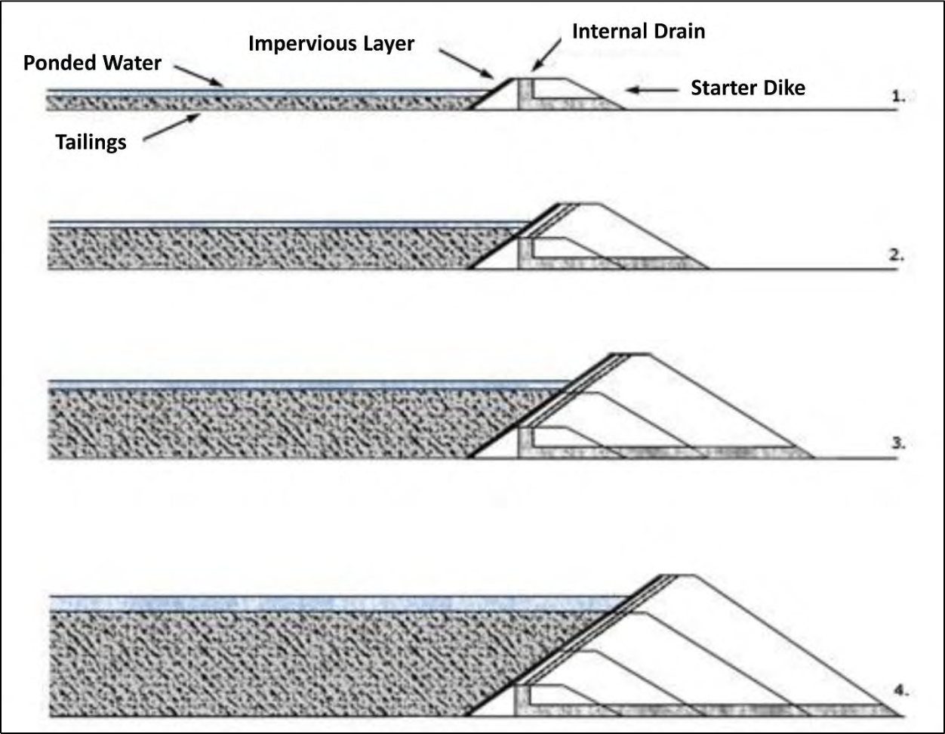
Figure 5b. In the downstream construction method, successive dikes are built in the downstream direction as the level of stored tailings increases. The dikes can be constructed out of waste rock, natural soil or the coarser fraction of tailings (with appropriate compaction). The ability to install impermeable layers and internal drains decreases the danger of dam failure due to overtopping, internal erosion, static liquefaction and foundation failure, all of which may result from excessive water. The seismic resistance is high because there are no uncompacted tailings underneath the dam. The disadvantage of the method is its high cost due to the amount of material required to build the dikes (compare the volumes of dikes in Figs. 5a and 5b). In fact, this construction method is not very different from the construction of an earthen water-retention dam (see Fig. 3). The differences are that a water-retention dam would be built entirely from a suitable natural soil (instead of tailings) and built completely before filling the reservoir with water. Figure modified from TailPro Consulting (2018).

The downstream construction method is the most expensive since it requires the most construction material (compare Figs. 5a and 5b). In this method, successive dikes are constructed in the downstream direction as the level of stored tailings increases. In fact, this construction method is not very different from the construction of an earthen water-retention dam (compare Figs. 3 and 5b). The differences are that a water-retention dam would be built entirely from a suitable natural soil (instead of tailings or waste rock) and would be built completely before filling the reservoir with water.

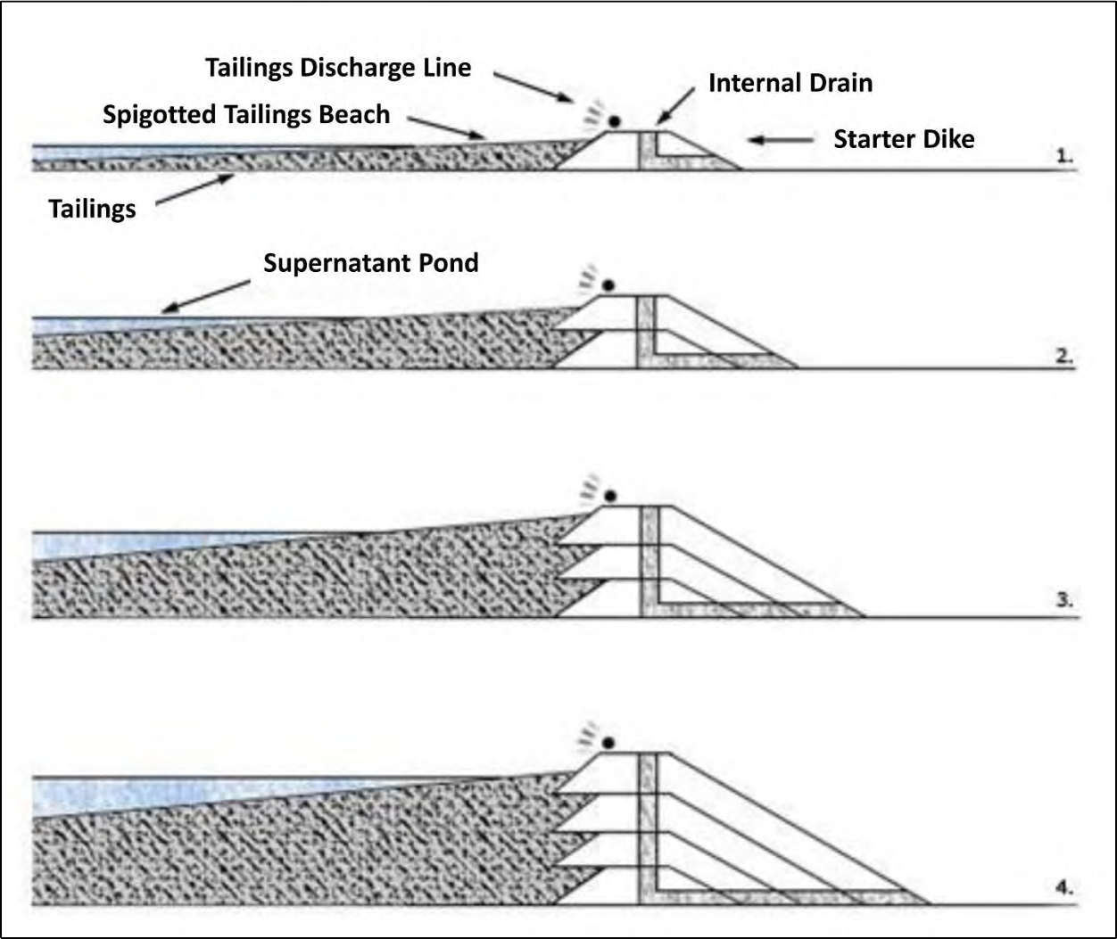
Figure 5c. In the centerline construction method, successive dikes are constructed by placing construction material on the beach and on the slope downstream of the previous dike. The center lines of the raises coincide as the dam is built upwards. The dikes can be constructed out of waste rock, natural soil or the coarser fraction of tailings (with appropriate compaction). The ability to install impermeable layers (see Fig. 8) and internal drains decreases the danger of dam failure due to overtopping, internal erosion, static liquefaction and foundation failure, all of which may result from excessive water. The centerline method is intermediate between the upstream and downstream methods (see Figs. 5a-b) in terms of cost and risk of failure. The seismic resistance is moderate because there are still some uncompacted tailings underneath the dikes. It is still necessary to maintain an adequate beach to prevent overtopping of the dam. Therefore, dams constructed by this method are suitable for temporary, but not permanent,
storage of water (Vick, 1990). Currently, the centerline construction method is the most common method of building tailings dams in the world. Figure modified from TailPro Consulting (2018).

The centerline construction method is a balance between the advantages and disadvantages of the downstream and upstream construction methods (compare Figs. 5a-c). In this method, successive dikes are constructed by placing construction material on the beach and on the slope downstream of the previous dike. The center lines of the raises coincide as the dam is built upwards (see Fig. 5c). Although there are few data on the frequency of different types of tailings dam construction (World Mine Tailings Failures, 2018), the centerline construction method is probably the most common method for building tailings dams in the world. The advantages and disadvantages of different types of construction in terms of their ability to resist catastrophic failures will be discussed after reviewing the common causes of failure of tailings dams.

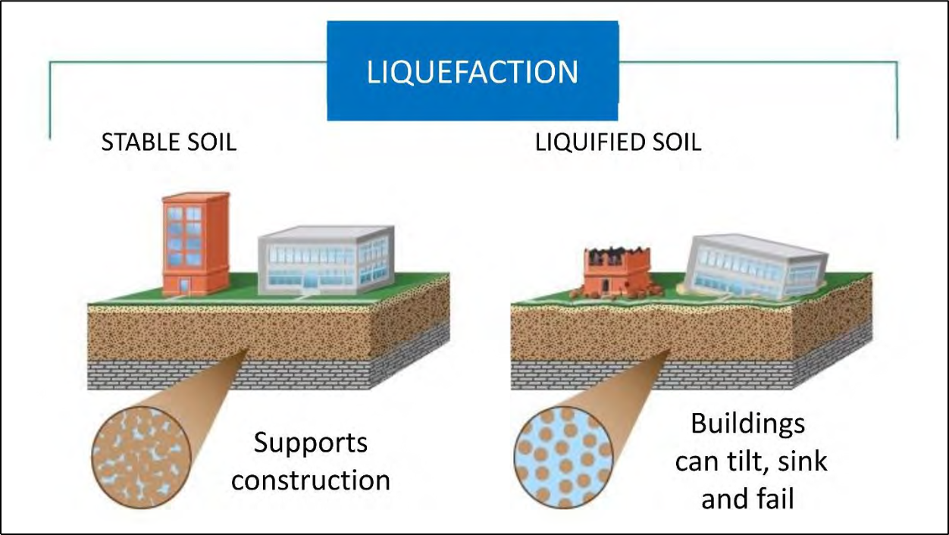
Figure 6. In a tailings deposit or natural soil, although there is interstitial water in the pores between the solid particles, the particles touch each other, so that the load is supported by the solid particles (and partially by the water). In the phenomenon of static liquefaction, a combination of excessive water and excessive loading causes the particles to separate, so that the interstitial water supports the entire load. As a result, the mass of solid particles and water behaves like a liquid. The phenomenon of seismic (or dynamic) liquefaction occurs when, during seismic shaking, the particles settle into a state of higher density. If this happened slowly, the water between the particles would be forced up and out of the spaces between the particles. However, because seismic shaking occurs so
rapidly, water does not have time to escape from between the particles. Instead, the water is compressed and the high water pressure causes the particles to separate so that they do not touch each other. Tailings ponds are especially susceptible to both static and seismic liquefaction because the tailings are very loosely packed due to the discharge into the pond without compaction (see Fig. 4).

Causes of Failure of Tailings Dams

The immediate cause of most catastrophic failures of tailings dams is the phenomenon of liquefaction (see Fig. 6). Normally, although there is interstitial water between the solid particles in soil or tailings, the particles touch each other so that the load is supported by the solid particles (and partially by the water). During liquefaction, the solid particles separate so that water enters

between the particles, the particles no longer touch each other, and the water supports the entire load. As a result, the mass of solid particles and water behaves like a liquid with no shear strength.
The five most important causes of failure of tailings dams are overtopping, earthquakes, static liquefaction, foundation failure, and internal erosion. Each of these five causes can be understood in terms of the phenomenon of liquefaction. The shaking that occurs during earthquakes causes the tailings to settle into a state of higher density. This settlement is much more common in tailings than in a natural soil because the tailings are very loosely packed due to the discharge into the pond without compaction (see Fig. 4). If the settlement occurred slowly,
the water between the particles would be forced up and out of the spaces between the particles. However, because seismic shaking occurs so rapidly, water does not have time to escape from between the particles. Instead, the water is compressed and the high water pressure causes the particles to separate so that they do not touch each other.

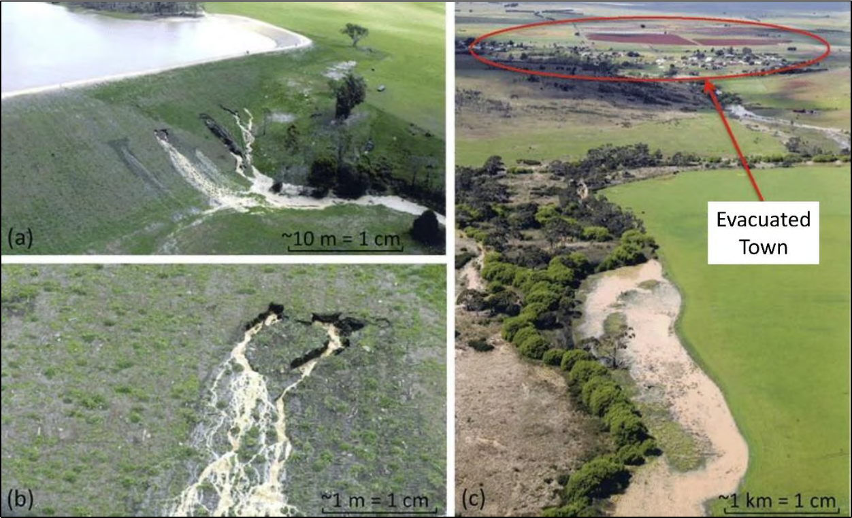
Figure 7. Internal erosion (also called piping) caused the failure of an earthen dam in Tunbridge, Australia, in 2005. During internal erosion, seepage washes solid particles out of the dam so that the dam loses its structural integrity. Internal erosion can be considered a type of liquefaction because the water supports the load of the dam. Internal erosion is promoted by an excessively steep embankment and the resulting high hydraulic gradient, forcing water to flow through the dam. Photo modified from Fisher et al. (2017).

In addition to the dynamic liquefaction that occurs during earthquakes, static liquefaction can occur simply due to the consolidation (settlement) of tailings. Static liquefaction can result from a combination of excessive load, excessive water and an excessive rate of tailings addition. If the permeability of the mass of tailings is low enough, then the tailings can be consolidated with insufficient time for the water to escape. Instead, the water is compressed and the high
water pressure causes the particles to separate so that they do not touch each other. As with seismic liquefaction, static liquefaction is promoted by the initial loosely-packed state of the

tailings. Failure of the foundation (the earth beneath the tailings management facility or beneath the dam itself) is also usually a type of static liquefaction. Foundation failure can occur when excessive loading or excessive water in the mass of tailings forces the water into a foundation that has insufficient permeability for the water to pass through the foundation.
Floods that cause water to overtop earthen dams almost always result in the complete failure of the dam. Water above the crest of the dam causes saturation of the dam and the excessive weight on top of the dam can force the separation of solid particles, which is a type of liquefaction. Floods can also destroy dams by removing the upper parts of the dam. In addition to spilling the contents behind the dam, the removal of the upper parts of the dam reduces the total weight of the dam and, therefore, the dam's ability to withstand the pressure of the material
behind the dam. In addition, tailings dams can fail simply due to water flowing over the embankment, which causes erosion of the dam.
The last common cause of failure of tailings dams is internal erosion, which occurs when
the seepage of water through the dam washes the tailings or other construction material out of the dam (see Fig. 7). Internal erosion can create an open pipe in the dam (so that internal erosion is also called piping), which causes the dam to lose structural integrity. Internal erosion can be considered a type of liquefaction because the water supports the load of the dam. Internal erosion is promoted by an excessively steep embankment and resulting high hydraulic gradient, forcing the water to flow through the dam (note the excessively steep embankment in Fig. 7). (The hydraulic gradient is the drop in the water table across the dam divided by the length of the dam.)

Methods of Construction and Causes of Failure

The common methods of tailings dam construction can now be analyzed in terms of their vulnerability to the common causes of tailings dam failures. It will not be surprising that the more expensive construction methods are also less vulnerable to failure. In particular, the upstream construction method is the most susceptible to failure during earthquakes. Since the upstream construction method builds the dam on top of the uncompacted tailings (see Fig. 5a), the liquefaction of these tailings will result in the inevitable collapse of the dam, since the dam
will have no support. For this reason, the upstream construction method is illegal in Chile, due to its high potential for strong earthquakes (Fourie et al., 2013) and even in Brazil, where the potential for large earthquakes is much lower (Imprensa Nacional [National Printer], 2019). In addition, the upstream construction method is the most susceptible to overtopping failures because the only infrastructure that prevents the pond from reaching the dam is the presence of the beach. The beach can be overtaken by the pond if there is heavy rainfall in the watershed of the tailings management facility or even if there is not enough sand in the tailings to form a suitable beach. For example, the tailings pond at the Highland Valley Copper mine has a very narrow beach, which hardly exists on the far side of the tailings pond (see Fig. 4). This narrow beach is probably the result of insufficient coarse particles in the tailings stream from the ore processing plant. (The tailings dam at the Highland Valley Copper mine was actually built by the centerline method. Although a suitable beach is still important, tailings dams built by the centerline method have other means to reduce the risk of overtopping, as explained below.)
It should be clear that lowering the water table within tailings management facilities and especially within the tailings dam can reduce the risk of all forms of liquefaction. The water table can be lowered in the downstream and centerline construction methods by installing low- permeability cores on the upstream side of the dam (see Figs. 5b and 8). In the upstream

construction method, there is no place to put a low-permeability core or an impermeable layer, so that any mention of an impermeable layer should indicate that the upstream construction method is not being used. Both the downstream and centerline construction methods allow the
installation of chimney drains and blanket drains (see Figs. 5b-c and 9), which are other ways of lowering the water table. The upstream construction method does not have any place to install a chimney drain (see Fig. 5a), although blanket drains are possible (see Fig. 9).

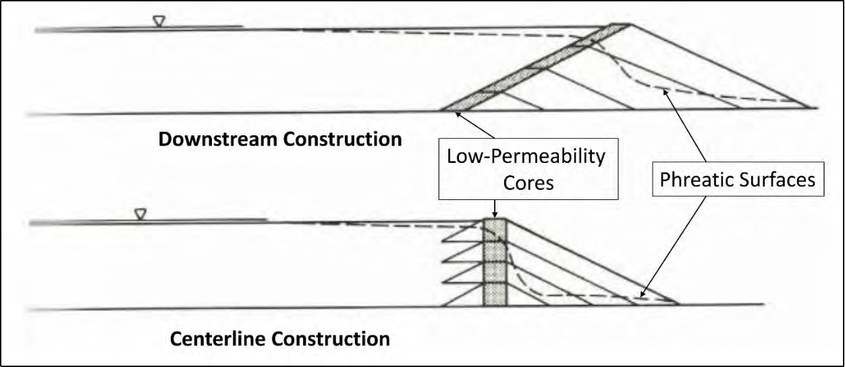
Figure 8. One of the advantages of the downstream and centerline construction methods is that it is possible to install low-permeability cores to lower the water table at the toe of the dam. This decrease in the water table reduces the likelihood of internal erosion of the dam (see Figure 7), static liquefaction of the dam, and foundation failure under the dam. These low-permeability cores are almost impossible to install when using the upstream construction method (see Fig. 5a). Figure modified from Vick (1990).

The possibility of internal erosion can also be reduced by lowering the water table. In addition, filters can be installed to prevent the transport of construction material out of the dam by seepage (see Fig. 3). These filters must be designed so that they trap fine particles, allow water to pass through (so that the water table is kept low), and not become clogged with fine particles. However, since the main driving force for internal erosion is the hydraulic gradient,
which is essentially the slope of the embankment, an inclination of 1V:1H (a vertical drop of one meter over a horizontal distance of one meter, equivalent to 45°), is considered as the maximum critical angle for the prevention of internal erosion (Le Poudre, 2015). According to the
European Commission (2009), “the upstream dam should have a downstream slope of less than
1V:3H.” In addition, the European Commission (2009) recommends that the slopes of the embankment should not be more pronounced than 1V:3H for any dam that stores tailings of base metals (including copper ores). The U.S. Army Corps of Engineers is even more conservative
and requires that “for sand levees, a 1V on 5H landside slope is considered flat enough to prevent damage from seepage exiting on the landside slope” (USACE, 2000). Although there is no database of embankment slopes for tailings dams, the author's experience is that a slope of
1V:2H (equivalent to 26.6° with respect to the horizontal) is the most common.
On the issue of preventing internal erosion, it is worth considering this passage from the standard textbook on geotechnical engineering by Holtz et al. (2011), “For practical problems, especially where there is a danger that i [the hydraulic gradient] could approach ic [the critical

hydraulic gradient], you should be very conservative in your design. Use a factor of safety of at least 5 or 6 in such cases. For one thing, failure is usually catastrophic and occurs rapidly and with little warning. For another, it is extremely difficult to know exactly what is going on underground, especially locally. Local defects, gravel pockets, etc., can significantly alter the flow regime and concentrate flow, for example, where you might not want it and not be prepared for it…Since failure of cofferdams is often catastrophic, it is extremely important that large factors of safety be used, especially where people's lives are at stake. Failures of earth structures resulting from piping have caused more deaths than all other failures of civil engineering structures combined. Therefore, your responsibility is clear – be careful and conservative, and be sure of your ground conditions and design.”

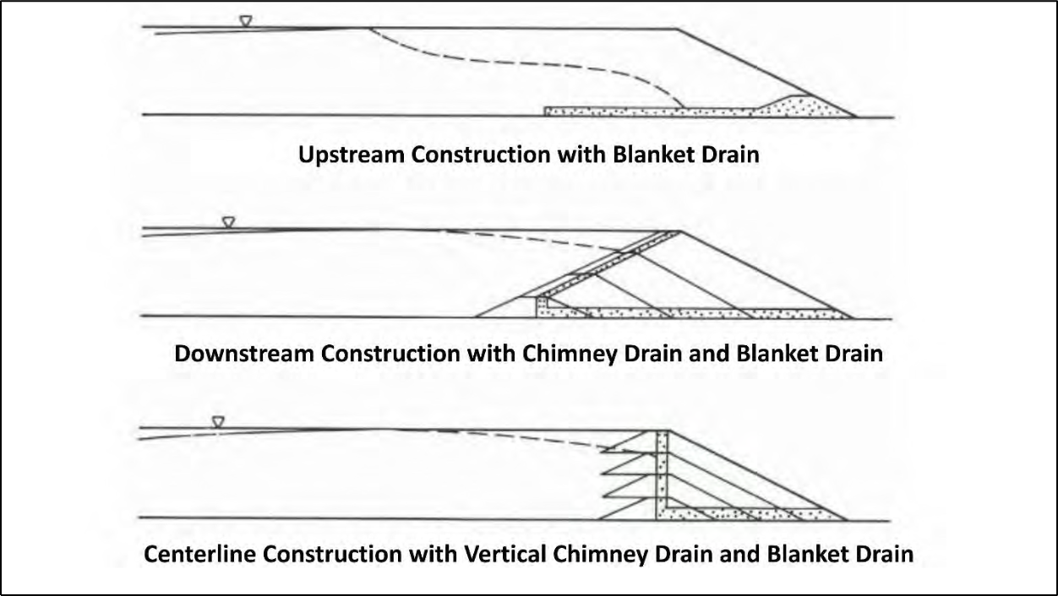
Figure 9. It is possible to install blanket drains using all three construction methods, although chimney drains can be installed using only the downstream and centerline construction methods. These drains lower the water table and reduce the likelihood of internal erosion of the dam (see Fig. 7), seismic liquefaction of the tailings, static liquefaction of the dam or tailings deposit, and failure of the foundation under the tailings. Figure modified from (1990).

Safety Criteria for Design of Tailings Dams

The most important step in designing dams in order to avoid catastrophic failures from floods and earthquakes is to choose the appropriate design flood and the appropriate design earthquake. The design earthquake is really a design seismic acceleration, which depends upon the magnitude of the design earthquake, the distance from the fault at which the earthquake is expected to occur, and the nature of the material under the dam. These design criteria depend on the hazard potential or the consequences of failure. For example, the (U.S.) Federal Emergency Management Agency classifies dams into three categories according to the hazard potential (FEMA, 2013). High Hazard Potential means “probable loss of life due to dam failure or misoperation.” It is clarified that “probable loss of life” refers to “one or more expected

fatalities” and that “economic loss, environmental damage or disruption of lifeline facilities may also be probable but are not necessary for this classification.” Significant Hazard Potential means “no probable loss of human life but can cause economic loss, environmental damage, or disruption of lifeline facilities due to dam failure or misoperation.” Low Hazard Potential means “no probable loss of human life and low economic and/or environmental losses due to dam
failure or misoperation.”
Each of the hazard potential classifications corresponds to an inflow design flood (FEMA, 2013). A dam with a Low Hazard Potential must be designed for a 100-year flood (flood with a 1% probability of exceedance in any given year) or “a smaller flood justified by rationale.” A dam with Significant Hazard Potential should be designed for a 1,000-year flood
(flood with an exceedance probability of 0.1% in any given year). However, a dam whose failure is expected to result in the loss of at least one life (High Hazard Potential) must be designed for the Probable Maximum Flood (PMF), which is defined as “the flood that may be expected from the most severe combination of critical meteorologic and hydrologic conditions that are reasonably possible in the drainage basin under study.” The magnitude of the PMF is normally derived from the Probable Maximum Precipitation (PMP), which is defined as “the theoretical greatest depth of precipitation for a given duration that is physically possible over a particular drainage area at a certain time of year.” The magnitudes of PMP have been determined for most of the United States (NWS-HDSC, 2017), as well as for most of the developed world. The procedures for determining the PMP have been described by the World Meteorological Organization (WMO, 2009). It is worth noting that, according to the U.S. Army Corps of Engineers, “the PMF does not incorporate a specific exceedance probability, but is generally thought to be well beyond the 10,000 year recurrence interval” (USACE-HCE, 2003).
In a similar way, each of the hazard potentials corresponds to a design earthquake. According to the Federal Emergency Management Agency, the Maximum Credible Earthquake (MCE) is “the largest earthquake magnitude that could occur along a recognized fault or within a particular seismotectonic province or source area under the current tectonic framework” (FEMA,
2005). In addition, for dams with High Hazard Potential, “the MDE [Maximum Design Earthquake] usually is equated with the controlling MCE.” Just as for design floods “where the failure of the dam presents no hazard to life, a lesser earthquake may be justified, provided there are cost benefits and the risk of property damage is acceptable.” In the same way, the U.S. Army Corps of Engineers has emphasized, “There is no return period for the MCE” (USACE, 2016). However, some older non-governmental guidelines, such as those of the (U.S.) National Fire Protection Association defined the MCE as “ground motion having a 2 percent probability of exceedance within a 50 year period (2475 year return period)” (NFPA, 2001).
The guidelines of the Canadian Dam Association (2013) are also widely recognized. These guidelines include five risk categories. The risk for any permanent population places a dam in the three highest risk categories, in which the high risk, very high risk and extreme risk
categories correspond to expected deaths of ten or less, 100 or less, and more than 100, respectively. The guidelines consider flood and earthquake design criteria based on both a risk- informed approach and a traditional, standards-based approach. According to the risk-informed approach, the minimum annual exceedance probability for the design flood or earthquake in the category of very high risk or extreme risk should be 1/10,000 (corresponding to a return period of 10,000 years). According to the traditional, standards-based approach, for a dam in the very high risk category, the design flood should be 2/3 between the 1,000-year flood and the PMF, while the design earthquake should be halfway between the 2,475 year earthquake and either the

10,000 year earthquake or the MCE. For a dam in the extreme risk category, the design flood should be the PMF, while the design earthquake should be either the 10,000-year earthquake or the MCE. There are many other guidelines for design floods in use worldwide and these were exhaustively reviewed by FEMA (2012).

DESIGN OF THE TAILINGS MANAGEMENT FACILITY AT THE MIRADOR MINE

Earlier Version and its Critiques

Before the submission of the first Environmental Impact Study for the Mirador mine in
2010 (Walsh Scientists and Engineers, 2010a-b, 2011a), EcuaCorriente S.A. hired Knight- Pièsold (2007) to review the design of the tailings management facility. The English-language review by Knight-Pièsold (2007) also contains an excellent summary of the design. The earlier design included the processing of 27,000 metric tons of ore per day with permanent storage of the tailings in the Quimi tailings management facility (see Fig. 2). The foundation of the facility would be alluvial soil with competent bedrock at a depth of 75-100 meters. The Quimi dam would be 63 meters high after its final raise and would be built using the centerline method with an outer embankment slope of 1V:2H (see Fig. 10). Ore processing would result in 2%
concentrate (intended for shipment for further processing), 87% coarser tailings (sands) and 11% finer tailings (slimes). The mixture of water and tailings would be transported to the Quimi tailings management facility without dewatering with 66.5% water content for the coarser
tailings and 79% water content for the finer tailings (weight percentage). The starter dike for the dam would be built with locally available natural soil. The construction material for the successive dikes would be obtained by cyclonic separation of the sand-sized tailings for separation of the coarsest fraction, estimated at 23% of the sand-sized tailings, which would be suitable for the construction of the dam. It was emphasized that “the entire cycloned sand production, based on the 23% recovery, is required to provide the quantity of fill required to raise the embankment during operations” (Knight-Pièsold, 2007).
A significant part of the design involved the means by which contamination of groundwater by acid mine drainage (AMD) would be avoided. The main component of AMD is sulfuric acid, which results from the oxidation of sulfide minerals after they are exposed to oxygen on the surface as tailings. If AMD is allowed to enter groundwater or surface water, it can negatively impact public water supply and aquatic organisms through acidification and
contamination by heavy metals that were part of the crystalline structure of the sulfidic minerals. Acidification of downstream rivers can also mobilize heavy metals that are stored in sediments in river beds. The possibility of AMD was addressed in the proposal to compact the natural soil to create a low-permeability layer at the base of the facility. In addition, it was found that only the finer tailings would be sulfidic and, therefore, potential generators of AMD. These finer tailings would be discharged below the level of the pond at the back of the tailings management facility
to prevent oxidation. Finally, “post-closure surface grading will ensure the cleaner [finer] tailings remain saturated in perpetuity” (Knight-Pièsold, 2007).
Based on the potential for loss of life and the environmental and economic consequences that would result from the failure of the tailings dam, Knight-Pièsold (2007) gave the tailings dam a risk assessment of VERY HIGH (its capitalization) using the classification system of the Canadian Dam Association (2013). Knight-Pièsold (2007) recommended that the dam be designed using the PMF as the safety criterion, which is even stricter than what is recommended

by the Canadian Dam Association (2013). However, Knight-Piesold (2007) admitted the difficulty of correctly estimating the PMF since “the available regional records [of precipitation] are not particularly long, nor are the data considered to be of exemplary quality.” Besides, “the only appropriate data that were obtained [for estimating streamflow] are for gauging stations on the Zamora and Sabanilla rivers, which are located to the southwest of the project area.” In addition, Knight-Pièsold (2007) recommended that the maximum design earthquake (MDE) should be the MCE, which is also stricter than what is recommended by the Canadian Dam Association (2013).

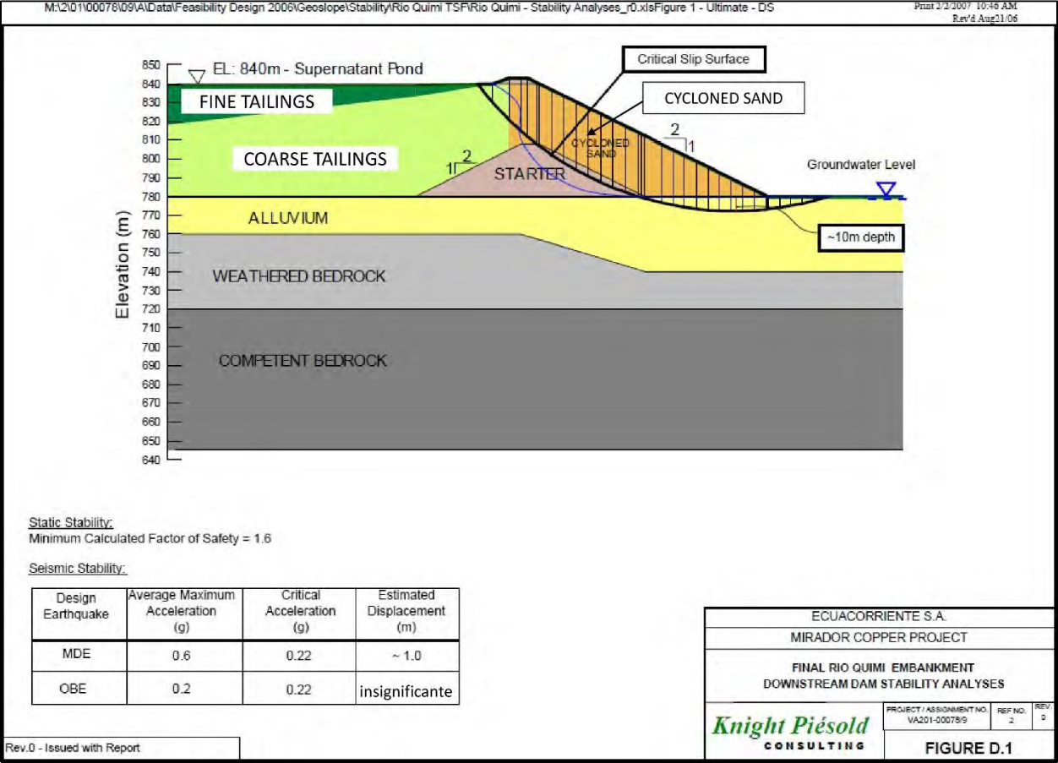
Figure 10. Knight-Pièsold (2007), consultants hired by EcuaCorriente S.A., determined that “the entire depth of the tailings deposit is potentially liquefiable for the MDE and OBE [Operating Basis Earthquake]. Liquefaction is also predicted for the loose alluvial soils near surface (in the upper 10 meters) for the MDE and OBE.” Knight-Pièsold (2007) identified the MDE (Maximum Design Earthquake) with the MCE (Maximum Credible Earthquake). The Operating Basis Earthquake is the earthquake that is expected to occur during the life of the project. Note that it was predicted that the maximum accelerations during the MCE and OBE would be 0.6g and 0.2g, respectively, while the critical acceleration for liquefaction was calculated to be 0.22g, where g is the acceleration due to gravity. Knight- Piesold (2007) recommended that “ground improvement to increase the liquefaction resistance of these loose soils will be required within the embankment footprint and for a distance downstream of the embankment. Stability analyses indicate that a 100 meter wide zone of ground will require treatment along the embankment alignment.” However, there were no details nor guarantees that the “ground improvement” would eliminate the possibility of liquefaction of the foundation. The Knight-Pièsold diagram (2007) clarifies that the earlier design of the Quimi tailings dam included centerline construction and an outer embankment slope of 1V:2H. Figure modified from Knight-Pièsold (2007).

The critical part of the Knight-Pièsold review (2007) was the seismic stability analysis, which said that “the entire depth of the tailings deposit is potentially liquefiable for the MDE and OBE [Operating Basis Earthquake]. Liquefaction is also predicted for the loose alluvial soils
near surface (in the upper 10 meters) for the MDE and OBE.” The OBE is the earthquake that is expected to occur during the life of a project. Knight-Piesold (2007) defined the OBE as the earthquake with a return period of 475 years, which is equivalent to an annual exceedance probability of 0.21% and a probability of exceedance during the 30-year life of the project of
6.13%. In other words, Knight-Piesold (2007) said the probability was 6.13% that the entire mass of tailings, as well as the foundation, will undergo seismic liquefaction at some time during the
30 years of the life of the project. However, it should be noted that the risk of seismic liquefaction does not end at the end of the mining project, but continues forever as the dam is supposed to store wet tailings in perpetuity. Knight-Piesold (2007) recommended that “ground improvement to increase the liquefaction resistance of these loose soils will be required within
the embankment footprint and for a distance downstream of the embankment. Stability analyses indicate that a 100 meter wide zone of ground will require treatment along the embankment alignment.” However, there were no details nor guarantees that the “ground improvement” would eliminate the possibility of liquefaction of the foundation. There is no evidence that this type of seismic stability analysis has ever been repeated, even when the proposed height of the tailings dam increased.
The description of the project in the subsequent Environmental Impact Study (Walsh Scientists and Engineers, 2010a-b, 2011a) differed little from the Knight-Pièsold (2007) report, except that the ore processing rate increased to 30,000 metric tons per day. Walsh Scientists and Engineers (2010b) clarified that “El embalse de relaves se mantendrá como una facilidad permanente posterior al cierre del proyecto” [The tailings reservoir will be maintained as a permanent facility after project closure] and that “una cobertura permanente de agua sobre los relaves proveerá de condiciones de anoxia, el cual prevendrá la generación de agua ácida,
manteniendo las condiciones neutras del lago” [a permanent water cover over the tailings will provide conditions of anoxia, which will prevent the generation of acidic water, maintaining the neutral conditions of the lake]. One of the comments of the Ministry of Environment of Ecuador was the convincing observation that “la estabilidad sísmica debe ser producto de un estudio de sísmica local de la zona del proyecto y no regional como ligeramente se lo ha realizado en el estudio. De igual manera con respecto a los deslizamientos de tierra que localmente podrían ocurrir en la zona del proyecto…” [the seismic stability must be the product of a local seismic study of the project area and not regional, as it has been minimally done in the study. Similarly, with respect to landslides that could occur locally in the project area…] (Walsh Scientists and Engineers, 2011b). The response of Walsh Scientists and Engineers (2011b) did not address the comment in any way, but simply referred to the attached report by Knight-Pièsold (2007), which also did not address the comment. The same document of responses to the Ministry of
Environment of Ecuador (2011b) included a map showing the distribution of tailings that would occur along the Rio Quimi after the dam collapsed (see Fig. 2). The initial surge of tailings was calculated using a formula (Jeyapalan et al., 1983) that has been shown to be based on incorrect assumptions and algebraic errors (Connors et al., 2016). The correct calculation of the initial surge will be treated in the Discussion section.
An independent review (not contracted by the mining company) included a wide range of critiques of the plan for the tailings management facility as it existed at that time (Kuipers,
2012). The most important critique from the point of view of prevention of catastrophic failures

was that the water content of the tailings (66.5% water for the coarser tailings and 79% water for the finer tailings) was excessively high. The most typical industry standards require partial dewatering of tailings to no more than 50% water before exporting them to tailings management facilities. On the contrary, it should be borne in mind that, in response to the failure of the
tailings dam at the Mount Polley mine, the Independent Expert Engineering Investigation and Review Panel (2015) recommended that all tailings be completely dewatered before storage. The most important critique from the point of view of the prevention of contamination of
groundwater was that Kuipers (2012) recommended a geosynthetic liner at the base of the facility, instead of relying on the low-permeability soil for the prevention of seepage from the facility.
Two other areas of critique addressed the design methodology and the financial guarantee. Kuipers (2012) criticized the explicit dependence on the “Observational Method” in Knight-Pièsold (2007). According to Independent Expert Engineering Investigation and Review
Panel (2015), “This commonly accepted approach uses observed performance from instrumentation data for implementing preplanned design features or actions in response.” Independent Expert Engineering Investigation and Review Panel (2015) repeated the concerns of Kuipers (2012) in affirming that “the Observational Method is useless without a way to respond to the observations.” Finally, Kuipers (2012) criticized AMEC's estimate (2004) that a financial guarantee of $55 million would be sufficient for the closure and reclamation of the mine, and
said that $568 million would be more reasonable. It is important to note that the financial guarantee estimate has not been reconsidered for the much larger project currently under construction.
Two other independent reviews questioned the accuracy of the predictions of the consequences of dam failure (Emerman 2014, 2015). Given that the tailings will spill into the Rio Quimi (see Fig. 2), after the initial surge, the flow of the rivers will carry the tailings even farther in the downstream direction. The termination of the flow of tailings at the confluence of
the Rio Quimi and the Rio Zamora was not justified by Walsh Scientists and Engineers (2011b). In fact, there is no reason why the transport of tailings should end at the confluence of these two very steep rivers. Emerman (2015) found that, under normal river flow, the finer tailings in suspension should reach the next main confluence with the Rio Santiago (approximately 88 km downstream of the confluence of the Rio Quimi and the Rio Zamora) in approximately 19 hours. If the collapse of the dam occurred during the annual maximum flow (flood with a return period of one year), the tailings would reach the Rio Santiago in just five hours.

Final Version and its Critiques

In 2014, a new Environmental Impact Study with a new consulting firm (Cardno,
2014a-b) proposed two alternatives to increase the ore processing rate from 30,000 metric tons per day to 60,000 metric tons per day. Alternative 1 (preferred by the mining company) was to replace the Quimi tailings management facility with the Tundayme tailings management facility (see Figs. 11-12) in the steep valley of the Rio Tundayme, which would have more space for tailings. Alternative 2 was to keep the Quimi tailings management facility, keep the tailings at a minimum water content by converting them into a paste, and add Portland cement to immobilize heavy metals. The advantage of dewatering was to reduce the volume of the tailings, so that
twice the mass of the tailings could be confined in the same space. While the both the Quimi and the Tundayme tailings management facilities were discussed throughout the Environmental

Impact Study, it is clear in Capítulo 5: Alternativas Estudiadas [Chapter 5: Studied Alternatives] of Cardno (2014a) that these were two alternatives, in which costs, environmental impacts and all other aspects were evaluated separately for each alternative.

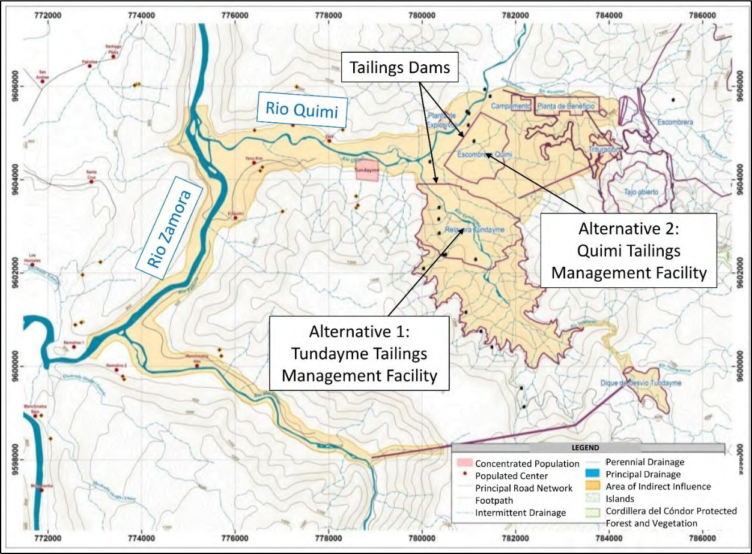
Figure 11. The second Environmental Impact Study (Cardno, 2014a) proposed two alternatives for increasing the production of copper ore from 30,000 to 60,000 metric tons per day. Alternative 1 was to replace the Quimi tailings management facility with the Tundayme tailings management facility, for which the dam would be 260 meters high, the tallest tailings dam ever built. Alternative 2 was to keep the Quimi tailings management facility, but increase its capacity by dewatering the tailings. Alternative 1 was preferred due to its lower cost, although it would have a greater environmental impact (Cardno, 2014a). Both alternatives are currently under construction, which is inconsistent with the Environmental Impact Study (Cardno, 2014a). Figure modified from Cardno (2014a).

The Tundayme dam had a planned height of 260 meters, which would be the tallest tailings dam in the world. (The current tallest tailings dam is the Quillayes dam at the Los Pelambres mine in Chile (Campaña et al., 2015)). The height of the Quimi dam remained unchanged at 63 meters. The outer embankment slopes were 1:1.5H and 1V:2H for the Tundayme dam and the Quimi dam, respectively. Although the construction methods were never explicitly stated, the discussion of the impermeable layers for both dams made it clear that the upstream construction method was not intended, as discussed above. For example, with respect
to the Tundayme dam, Cardno (2014a) wrote “En el talud aguas arriba del dique inicial se colocarán instalaciones impermeables (una capa impermeable y una capa de filtro). La capa impermeable consiste en geotextil de 2 mm + esteras de bentonita (4800 g/m2)” [On the

upstream slope of the starter dike, impermeable infrastructure (an impermeable layer and a filter layer) will be placed. The impermeable layer consists of 2 mm geotextile + bentonite mats (4800 g/m2)]. The storage volume of the Tundayme tailings management facility was 380,097,000 m3. The storage volume of the Quimi tailings management facility could be correspondingly smaller due to the removal of water from the tailings.

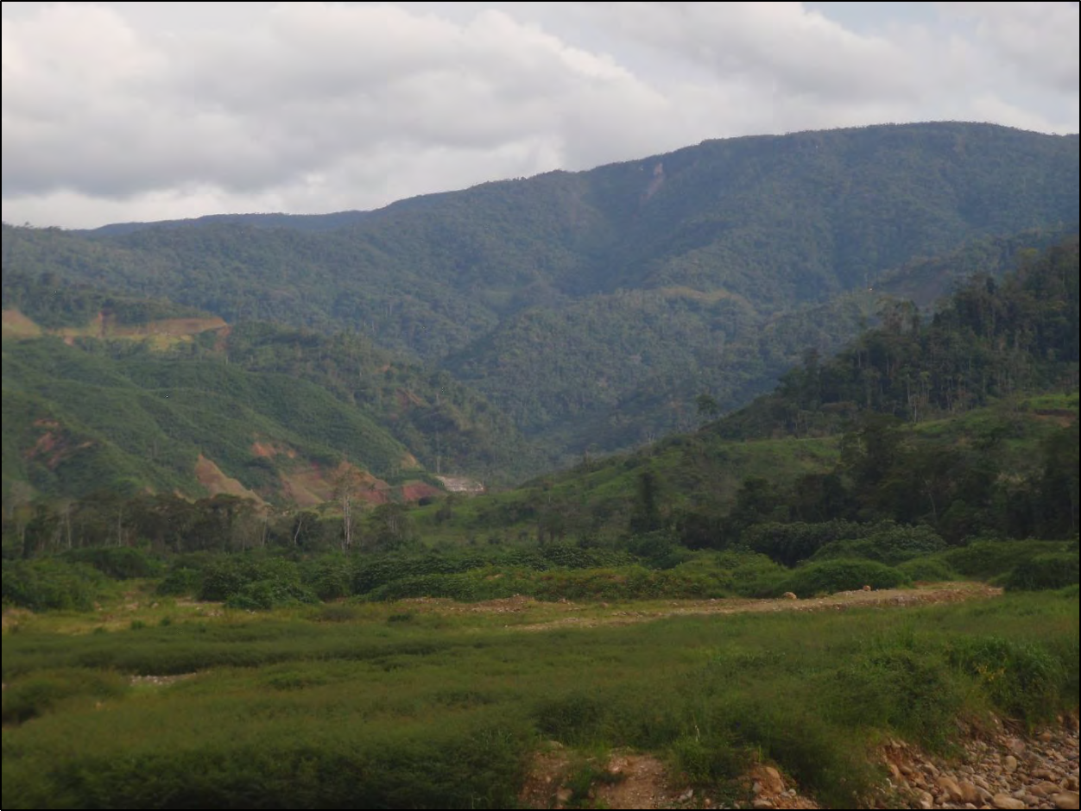
Figure 12. The cost of construction would be cheaper for the Tundayme tailings management facility because it is possible to take advantage of the steep slopes of the Tundayme valley (shown above) for confinement of the tailings (Cardno, 2014a). However, the steep slope of the valley (around 13%) in the direction towards the Rio Quimi (see Fig. 11) increases the risk of failure due to the increase in gravitational force that would act on the dam. In addition, steep side slopes pose a risk of landslides into the tailings pond, which could cause dam failure by overtopping. Photo taken by the author on November 6, 2018.

An important change compared to the earlier Environmental Impact Study was the reduction in the magnitude of the design flood from the earlier choice of the Probable Maximum Flood. The design flood for the Tundayme dam was the 500-year flood during the first five
years, at which time the dam would be 90 meters high. The design flood was the 1000-year flood until the end of the ninth year, when the dam would be 155 meters high. After the ninth year, the design flood would be increase to the PMF. The reduction in the magnitude of the design flood was presumably an inappropriate response to the greater flooding that would occur in the Tundayme Valley. According to Cardno (2014a), “La relavera Tundayme se ubica aguas abajo del río Tundayme, ocupando una gran área para el escurrimiento de agua lluvia en la zona

superior del río (52 km2). Debido a los grandes caudales, se dificulta el control de inundaciones en temporadas lluviosas” [The Tundayme tailings management facility is located downstream of the Rio Tundayme, occupying a large area for runoff of rainwater in the upper area of the river (52 km2). Due to the large flows, flood control is difficult in the rainy seasons]. In general, much less information was available on the Quimi dam than on the Tundayme dam, presumably because the Tundayme dam was the preferred alternative.

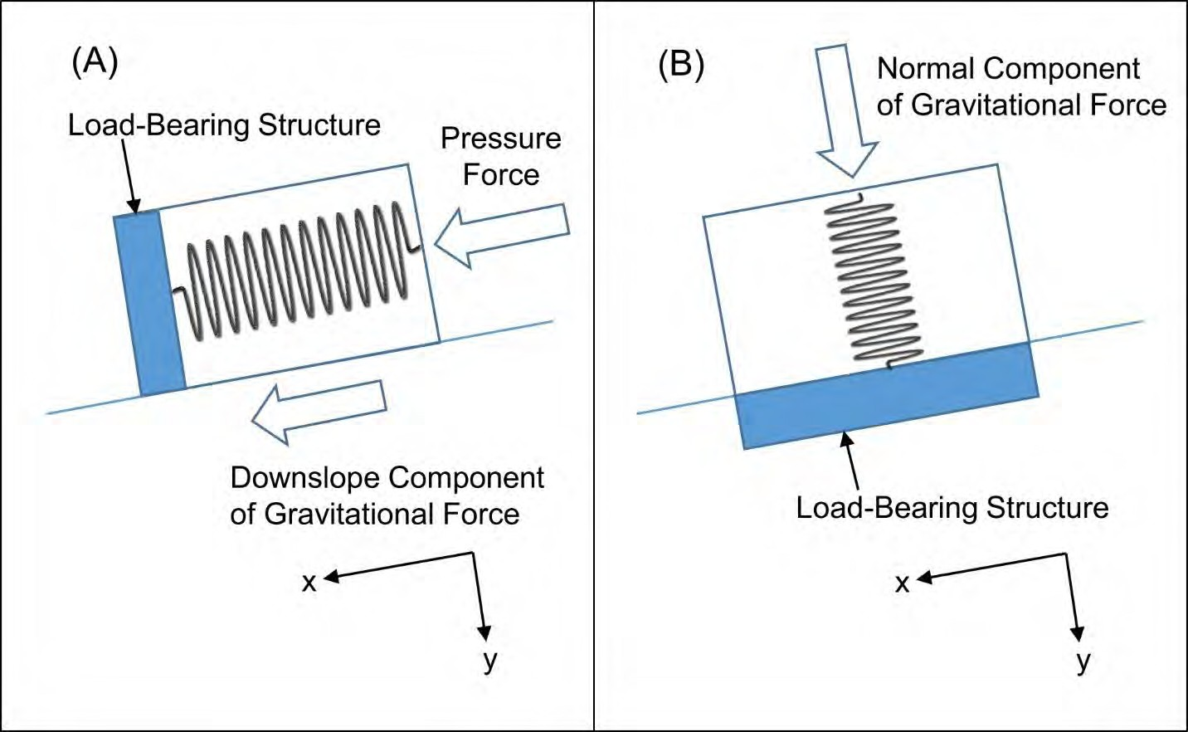
Figure 13. A loaded spring is the simplest model for any deformable solid that has not been stressed beyond its yield point. (A) In the case of a concrete dam, there are some load-bearing structures (shown here as a single reinforced column) that prevent the movement of the dam in the downslope direction (x-direction). Most earthen dams and all tailings dams lack reinforced columns or other defined load-bearing structures, so that the load is supported by the entire dam. The dam acts as a spring oriented in the downslope direction (x-direction) that is compressed against the load-bearing structure by the pressure force of the mixture of water and tailings upstream of the dam and by the downslope component of the gravitational force. (B) The dam could also be considered as a spring oriented in the y-direction and which is being compressed by the normal component of gravity. In this case, the foundation of the dam acts as the load-bearing structure. Figure from Emerman (2016).

The new Environmental Impact Study (Cardno, 2014a-b) did not include any new
seismic stability analysis, although the preferred dam (the Tundayme dam) was in a new location with a different foundation, the height of the dam had increased from 63 meters to 260 meters,
the slope of the embankment had increased from 1V:2H to 1V:1.5H, and the dam was in a steeper valley (both along the sides and downslope towards the Rio Quimi). As an attempt to estimate the stability of the preferred dam, Emerman (2016) calculated the change in the relative risk of failure that would result from changing the height of the dam, the height of the tailings, and the density of the mixture of tailings and water (collectively called the scale and mode of operation), without other changes in the design of the dam. The calculation was carried out by

modeling the tailings dam as a set of loaded springs and using the compressions of the springs as a measure of progress towards failure (see Fig. 13). It was found that

����,2(��/��0 )2��2

��� = 𝜌
(��/𝐻 ) 𝐻
(1)

��,1
0 1 1

��0,2
2
��� = ( )
��0,1

(2)

where Rx is the relative risk of failure in the downslope direction, Ry is the relative risk of failure in the normal direction (gravitational collapse), ρT is the density of the mixture of tailings and water, H0 is the height of the dam, H is the height of the tailings, and the subscripts “1” and “2” refer to the first and second scales and modes of operation, respectively (see Fig. 14). It was found that the valley slope β was a less important factor and Eqs. (1) - (2) are simplified expressions that neglect the valley slope (see Fig. 14). Using the parameter values available in Cardno (2014a), Emerman (2016) found that, in comparison to the original plan (called Alternative 3 in Cardno (2014a)), the risk of failure in the downslope direction increased by a factor of 17.03 for Alternative 1 (Tundayme dam), while the risk of normal failure (gravitational collapse) increased by a factor of 1.76 for Alternative 2 (Quimi dam with dewatered tailings).

METHODOLOGY

The objective of this report has been to answer the following question: Are the design and the construction of the tailings dams consistent with widely-recognized safety guidelines? After reviewing the construction and causes of failure of tailings dams, and the history of tailings dam design at the Mirador mine, the question can be divided into the following questions:
1) Were the dams designed with the correct safety criteria for floods and earthquakes?
2) Is the use of non-sulfidic tailings appropriate for the construction of the tailings dams?
3) Are there additional risks of failure of the tailings dams that were not addressed in the
Environmental Impact Studies or in the critiques discussed above?
4) Is the current construction consistent with the designs?
The questions were addressed by comparing the information from the most recent Environmental Impact Study (Cardno 2014a-b) with the standard textbook on tailings dams (Vick, 1990), as well as with widely-recognized guidelines for the choice of design floods and
earthquakes (Canadian Dam Association, 2013; FEMA, 2005, 2013). Additional information was obtained from a complaint against EcuaCorriente S.A. by the provincial government of Zamora Chinchipe (Quishpe Lozano et al., 2018). The written information was complemented with
photos taken by the author on November 6, 2018, during a visit in the company of Luis Sánchez Zhiminaycela (activist with Comunidad Amazónica de Acción Social Cordillera del Cóndor Mirador; see Fig. 1) and Evelyne Blondeel from E-Tech International. We were not allowed to enter the mine site and all photos were taken from the highway that borders the mine site. It is possible that the answers to my concerns are found in other technical documents that could not
be consulted. However, it should be kept in mind that writing this report involved studying 6,384 pages of information produced by the company and its consultants.

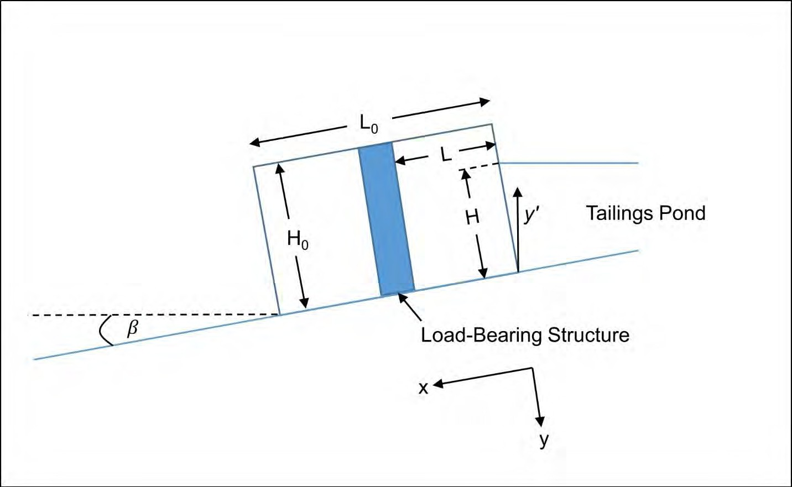
Figure 14. Although the geometry of the earthen dam is greatly simplified, it still captures all the forces acting on the dam and the resistances to those forces. The variable L is the spacing in the downslope direction between the reinforced columns or other load-bearing structures, which is shown here as the downslope distance between the upstream edge of the dam and a single load-bearing structure. Since tailings dams lack reinforced columns or other defined load-bearing structures, the load is supported by the entire dam, so that L = L0. Figure from Emerman (2016).

Although the guidelines mentioned above do not legally apply in Ecuador, EcuaCorriente
S.A. relied on their compliance with the guidelines of the Canadian Dam Association (2013) in its Environmental Impact Study (Walsh Scientists and Engineers, 2010a) and in its responses to questions from the Ministry of Environment of Ecuador (Walsh Scientists and Engineers, 2011). Therefore, it should be assumed that EcuaCorriente S.A. intends to comply with the guidelines of the Canadian Dam Association (2013) in all aspects of the project. Certainly, a project that was legal in Ecuador but was inconsistent with internationally-recognized guidelines should be a cause for pause and reflection.

RESULTS

Safety Criteria for Floods and Earthquakes

It should be clear at this point that the use of the 500-year flood as the safety criterion for the Tundayme dam is completely inappropriate. The recommendation of the Probable Maximum Flood for the Quimi dam (much smaller than the Tundayme dam) by Knight -Pièsold (2007) was based on their judgment that failure “would have a significant environmental impact on downstream watercourses. The economic consequences and socio-economic impact…would also be very high.” According to Knight-Pièsold (2007), the Quimi dam would be at the point of failure during the 475-year earthquake (see Fig. 10). Their seismic stability analysis was not

repeated for the much taller Tundayme dam. The relevant risk category corresponding to the design for a 500-year event is “significant” according to the Canadian Dam Association (2013). Using the risk-informed approach, a dam with “low” risk should be designed for a 100-year event, while a dam with “significant” risk should be designed for a 1,000-year event. Using the traditional, standards-based approach, a dam with “significant” risk should be designed for an event with a return period of between 100 and 1,000 years. The interpretation of “significant”
risk is that there is a risk only for a temporary population (“seasonal cottage use, passing through on transportation routes, participating in recreational activities”), the restoration of cultural and environmental values or compensation in kind is “ highly possible,” and there will be economic losses only to “recreational facilities, seasonal workplaces and infrequently used transportation routes” (Canadian Dam Association, 2013). It should be clear that the "significant" risk category is irrelevant for a dam that is 1000 meters upstream of the inhabited town of Tundayme.

Use of Non-Sulfidic Tailings for the Construction of the Tailings Dams

The prediction that the coarser tailings will non-sulfidic (non-acid generating) and that only the finer tailings will be sulfidic (potentially acid generating) was based on an analysis of only 21 samples (Walsh Scientists and Engineers, 2010a). This is a very small set of samples, especially compared to the size of the ore body that will be converted into tailings. None of the available documents indicates the size of the rock samples. However, a published procedure establishes that measurements of neutralization potential and acidity potential were made in
samples of two grams (Skousen et al., 2001). On that basis, 21 × 2 grams = 42 grams represents
less than 10-13 (less than one part in ten trillion) of the planned 657 million metric tons of mine
tailings (60,000 metric tons per day for 30 years). In addition, none of the documents contains any measure of uncertainty (error limits) in the prediction that 87% of the ore processed will be converted into coarser tailings (assumed to be non-sulfidic).
There is no guarantee, or even estimate of the probability, that there will be enough non- sulfidic tailings to build the dams. There are two possible responses to a future discovery of the lack of non-sulfidic tailings for construction:
1) Sulfidic tailings will be used to build the dams or there will be a change in the cut-off value that defines the sulfide content that counts as “sulfidic.” Any of these changes will involve the generation of acid mine drainage (AMD) from the unconfined dams.
2) There will be a change in the design of the dam to adapt to the lack of construction material.
For example, the slope of the embankment will become steeper or there will be a change from centerline construction to upstream construction, which requires less construction material.
As Kuipers (2012) and the Independent Expert Engineering Investigation and Review Panel (2015) mentioned, the “Observational Method” makes sense only if they are ways of adapting to the new observations.

Additional Risks of Failure of the Tailings Dams

None of the documents provided by EcuaCorriente S.A. nor their consultants have addressed the risk of landslides, despite the fact that the Ministry of Environment of Ecuador (Walsh Scientists and Engineers, 2011b) asked them to provide this information. The problem is particularly serious in the steep valley of the Rio Tundayme (see Fig. 12). From the point of view

of cost reduction, one of the advantages of this site is that it is possible to use the slopes as walls for the Tundayme tailings management facility, as opposed to the Quimi tailings management facility, which requires the construction of walls on three sides of the tailings reservoir (Cardno,
2014a; see Fig. 1). The main threat of landslides is that rocks falling in the tailings pond could cause water to flow over the top of the dam, which would almost certainly destroy the dam. The high erosion rate in the project area is indicated by the landslide scar below a transmission tower on the north bank of the Rio Quimi, opposite the Quimi tailings dam (see Figs. 11 and 15). The landslide scar also indicates the underestimation of the erosion rate by the engineers who chose the site for the transmission tower that provides electricity for the mine.

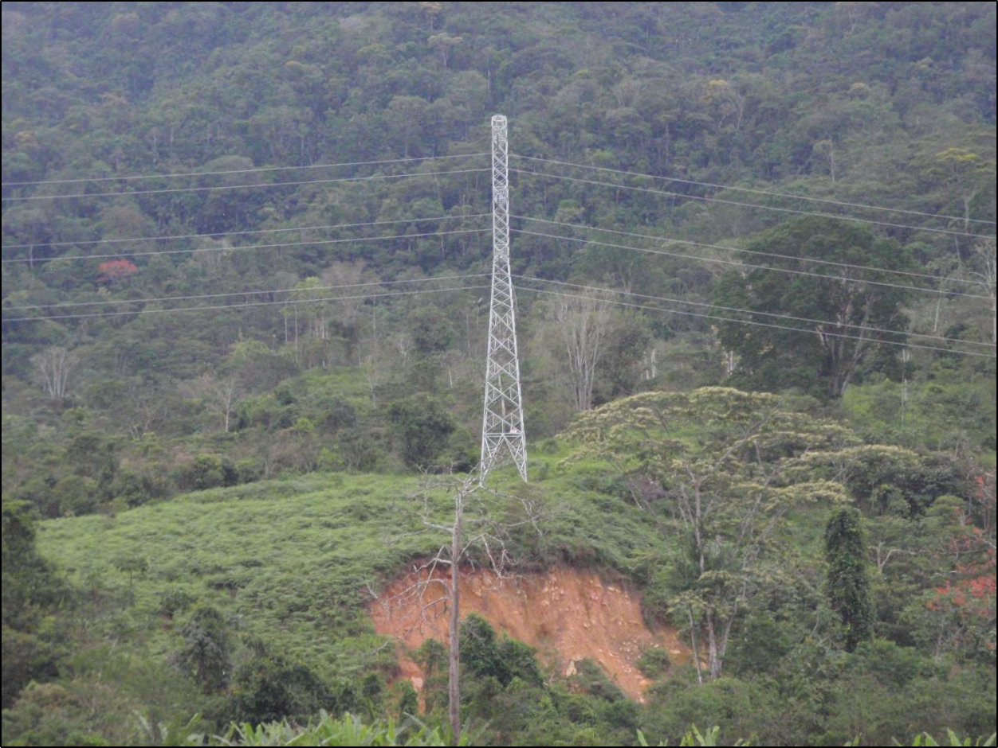
Figure 15. The high erosion rate in the project area is indicated by the landslide scar below a transmission tower on the north bank of the Rio Quimi (see Fig. 11), opposite the Quimi tailings dam. Photo taken by the author on November 6, 2018.

Contradictions between Construction and Design

There are three important contradictions between the current construction and the design of the tailings management facilities at the Mirador mine. The first is that the Quimi dam is being built using the upstream method. The starter dike for the Quimi tailings dam was built on the
edge of the highway, the other side of which is the Rio Quimi (see Figs. 11 and 16). Since it is
not possible to advance the dam farther in the downslope direction, the intention must be to build

the entire dam using the upstream method (compare Figs. 5a-c). This is inconsistent with the design evaluated by Knight-Pièsold (2007) and both Environmental Impact Studies (Walsh,
2010b; Cardno, 2014a), which included the centerline construction method for the Quimi tailings dam. Tailings dams built by the upstream method are more susceptible to failures from both earthquakes and floods. Due to the impossibility of installing impermeable layers (see Figs.5a-c,
8), their higher water content also makes them more susceptible to failure due to internal erosion, static liquefaction and foundation failure.

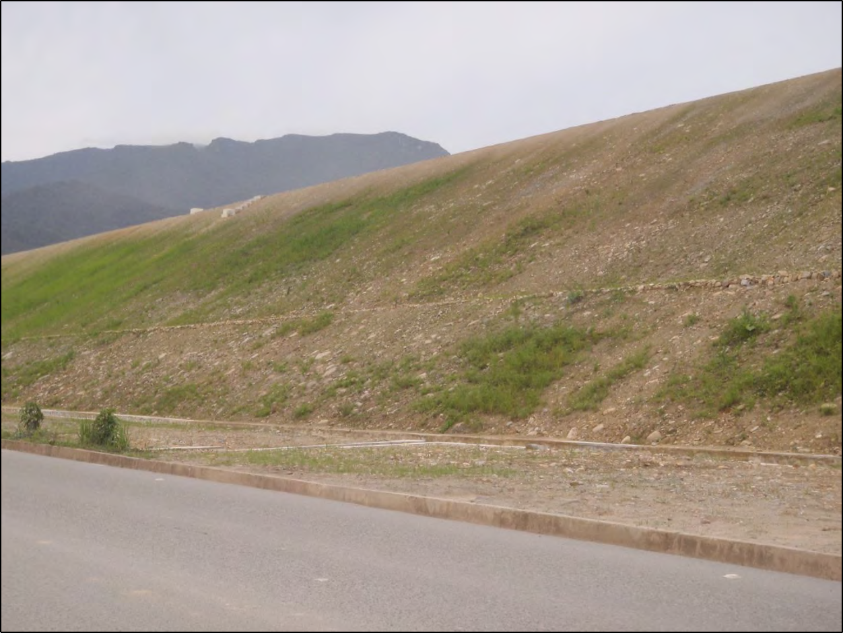
Figure 16. The starter dike for the Quimi tailings dam was built at the edge of the highway, the other side of which is the Rio Quimi (see Fig. 11). Since it is not possible to advance the dam farther in the downslope direction, the intention must be to build the entire dam using the upstream method (compare Figs. 5a-c). This is inconsistent with the design evaluated by Knight-Pièsold (2007) and both Environmental Impact Studies (Walsh Scientists and Engineers, 2010b; Cardno, 2014a), which included the centerline construction method for the Quimi tailings dam. Tailings dams built by the upstream method are more susceptible to failure from both earthquakes and floods. Due to the impossibility of installing impermeable layers (see Figs. 5a-c, 8), their higher water content also makes them more susceptible to failure due to internal erosion, static liquefaction and foundation failure. Photo taken by the author on November 6, 2018.

The second contradiction is that a simple application of trigonometry shows that the starter dike of the Quimi dam (see Fig. 17) has a slope of 1V:1H (45°). This is inconsistent with the design evaluated by Knight-Pièsold (2007; see Fig. 10) and both Environmental Impact Studies, which stated that the slope would be 1V:2H (26.6°). As explained above, a slope of

1V:1H is considered to be the maximum critical angle to prevent internal erosion of the dam without any margin of error (safety factor = 1.0). In other words, the starter dike was built at the point of failure, and is in danger of failing as soon as the tailings management facility is filled with wet tailings.

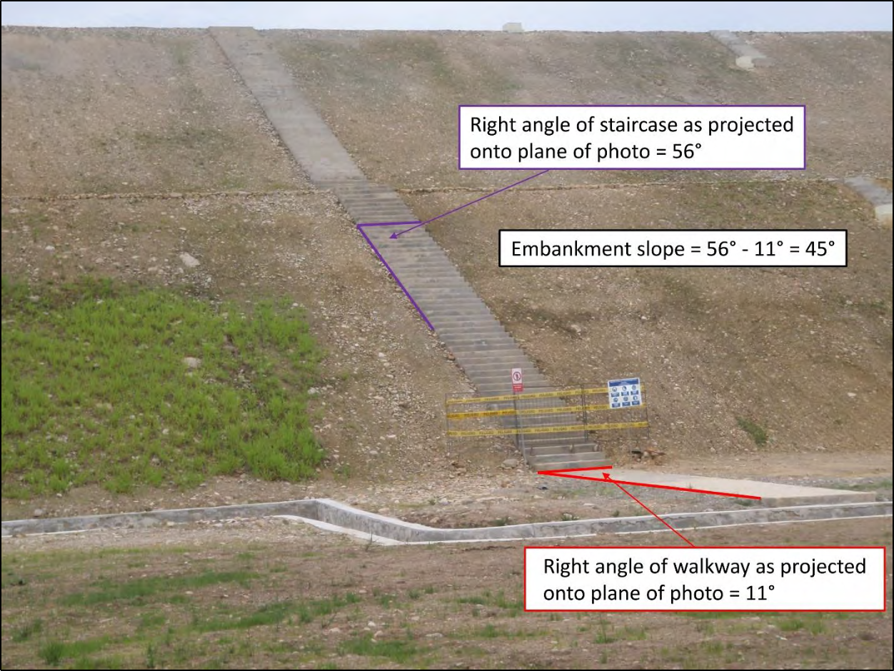
Figure 17. The starter dike for the Quimi tailings dam has a slope of 1V:1H (45°). This is inconsistent with the design evaluated by Knight-Pièsold (2007; see Fig. 10) and both Environmental Impact Studies, which stated that the slope would be 1V:2H (26.6°). A slope of 1V:1H is considered the maximum critical angle to prevent internal erosion of the dam without any margin of error (safety factor = 1.0). In contrast, according to the U.S. Army Corps of Engineers (USACE, 2000), “for sand levees, a 1V on 5H landside slope [11.3°] is considered flat enough to prevent damage from seepage exiting on the landside slope.” Photo taken by the author on November 6, 2018.

The most surprising contradiction of all is that both tailings management facilities, Quimi and Tundayme, are currently under construction, although according to the most recent Environmental Impact Study (Cardno, 2014a-b), these were simply two alternatives (see Figs. 1,
11, 16, 17 and 18). There are at least three possible interpretations of the appearance of the two tailings management facilities:
1) The mine will process 60,000 metric tons of ore per day using both tailings management facilities to store the tailings.
2) The mine will process 90,000 metric tons of ore per day by storing 60,000 metric tons of wet tailings per day in the Tundayme tailings management facility and 30,000 metric tons of wet tailings per day in the Quimi tailings management facility.

3) The mine will process 120,000 metric tons of ore per day by storing 60,000 metric tons of wet tailings per day in the Tundayme tailings management facility and 60,000 metric tons of dewatered tailings per day in the Quimi tailings management facility.
It is impossible to decide which interpretation is correct when there is no apparent connection between the designs and the actual construction. In the same way, it is impossible to determine whether there is an intention to store wet tailings behind the Quimi dam, which would have an unacceptable risk of failure by internal erosion due to its excessively steep slope (see Fig. 17).

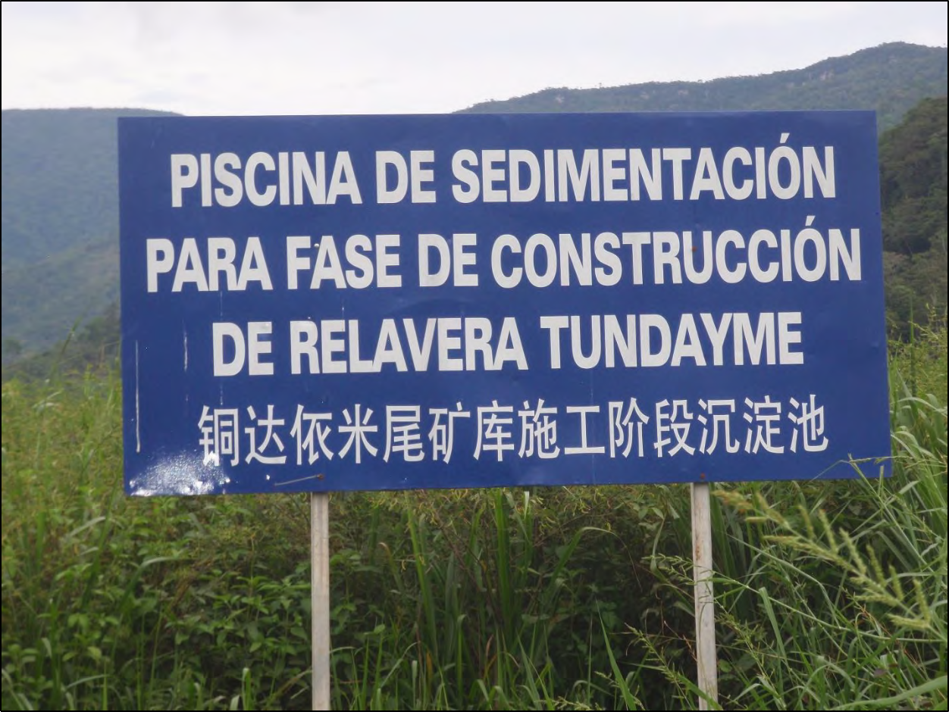
Figure 18. The sign (“Sedimentation Pond for Construction Phase of Tundayme Tailings Management Facility”) clarifies that both the Quimi tailings management facility (see Figs. 1, 16 and 17) and the Tundayme tailings management facility are currently under construction. This is inconsistent with the Environmental Impact Study (Cardno, 2014a), which listed the two tailings management facilities as alternatives. Photo taken by the author on November 6, 2018.

The Tundayme tailings management facility is not even being built with due respect for the protection of the Rio Quimi. Sedimentation ponds are supposed to prevent the flow of muddy water from the construction site from entering the Rio Quimi. However, the overflow from the sedimentation ponds for the Tundayme tailings management facility is discharged into a pipe and flows into the Rio Quimi (see Figs. 19a-b). The gray color of the discharge from the sedimentation ponds demonstrates that the sedimentation ponds are not working (see Fig. 19c), which was also observed by Quishpe Lozano et al. (2018). It is very likely that the sedimentation

ponds have not been constructed correctly, so that surface runoff simply flows over the top of the ponds without time for the sedimentation of fine particles.

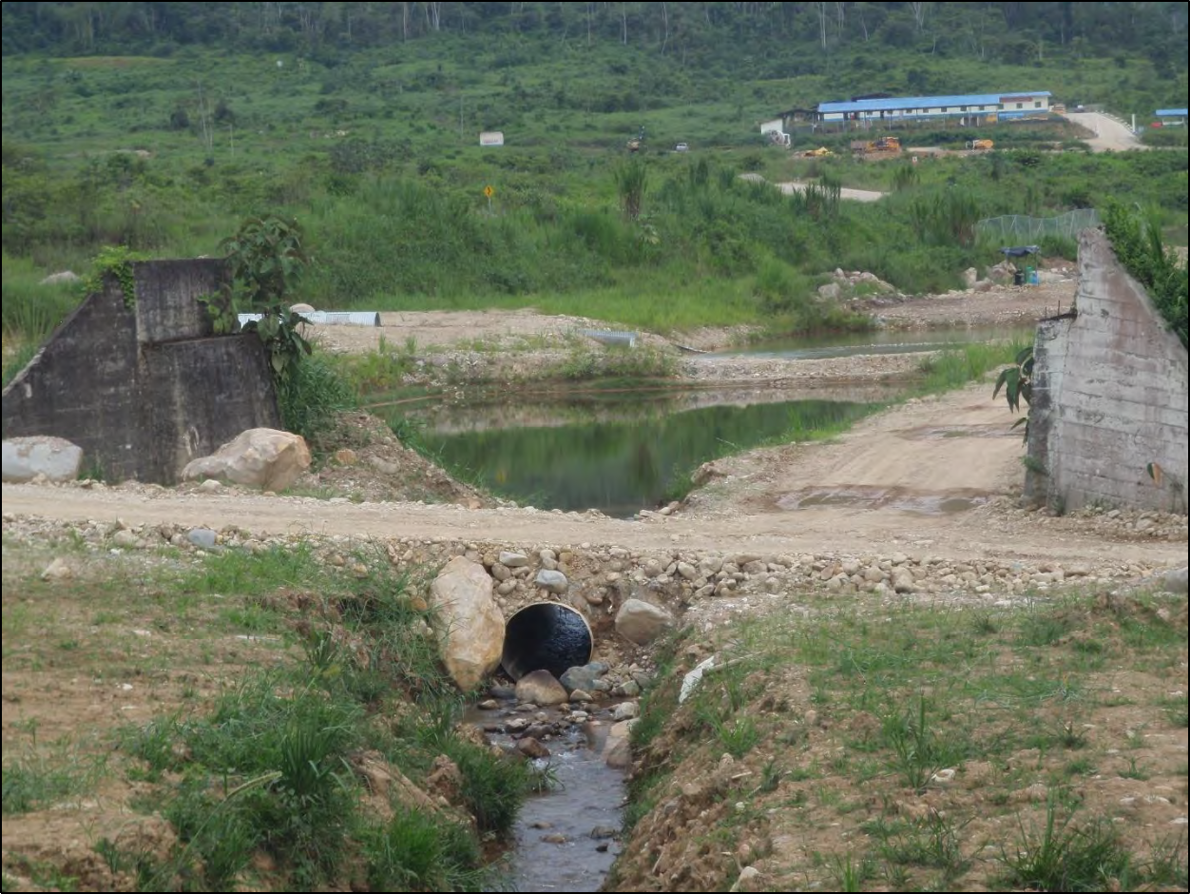
Figure 19a. The overflow from the sedimentation ponds for the Tundayme tailings management facility is discharged into a pipe and flows to the Rio Quimi (see Fig. 11). Photo taken by the author on November 6, 2018.

DISCUSSION

Explanation for the Contradictions between Construction and Design

A possible explanation for the change from centerline construction to upstream construction (see Fig. 16) and the excessively steep slope of the starter dike (see Fig. 17) can be found in a complaint by the provincial government of Zamora Chinchipe against EcuaCorriente S.A. According to the complaint “Aquí se realizaba la extracción de material pétreo en una porción del río Tundayme. Al igual que en los ríos Quimi y Waywayme [ver Figs. 2 y 11], la extracción de material pétreo en esta zona no se realiza dentro de ninguna concesión minera para la explotación de áridos y pétreos…Cabe resaltar que en la revisión realizada al Catastro Minero nacional no se registran títulos mineros para la explotación de material pétreo dentro del proyecto Mirador en la zona antes mencionada” [Here the extraction of rock material was carried out in a portion of the Rio Tundayme. As in the Rio Quimi and the Rio Waywayme [see Figs. 2 and 11], the extraction of rock material in this area is not carried out within any mining concession for the exploitation of aggregates and rock…It should be noted that in the review

conducted for the National Mining Registry, mining titles are not registered for the exploitation of rock material within the Mirador project in the aforementioned area] (Quishpe Lozano et al.,
2018). A possible explanation for the illegal extraction of construction material from rivers is the lack of other sources of construction material. Less construction material is required to build a dam using the upstream construction method (compare Figs. 5a and 5c) and to build a steeper embankment.

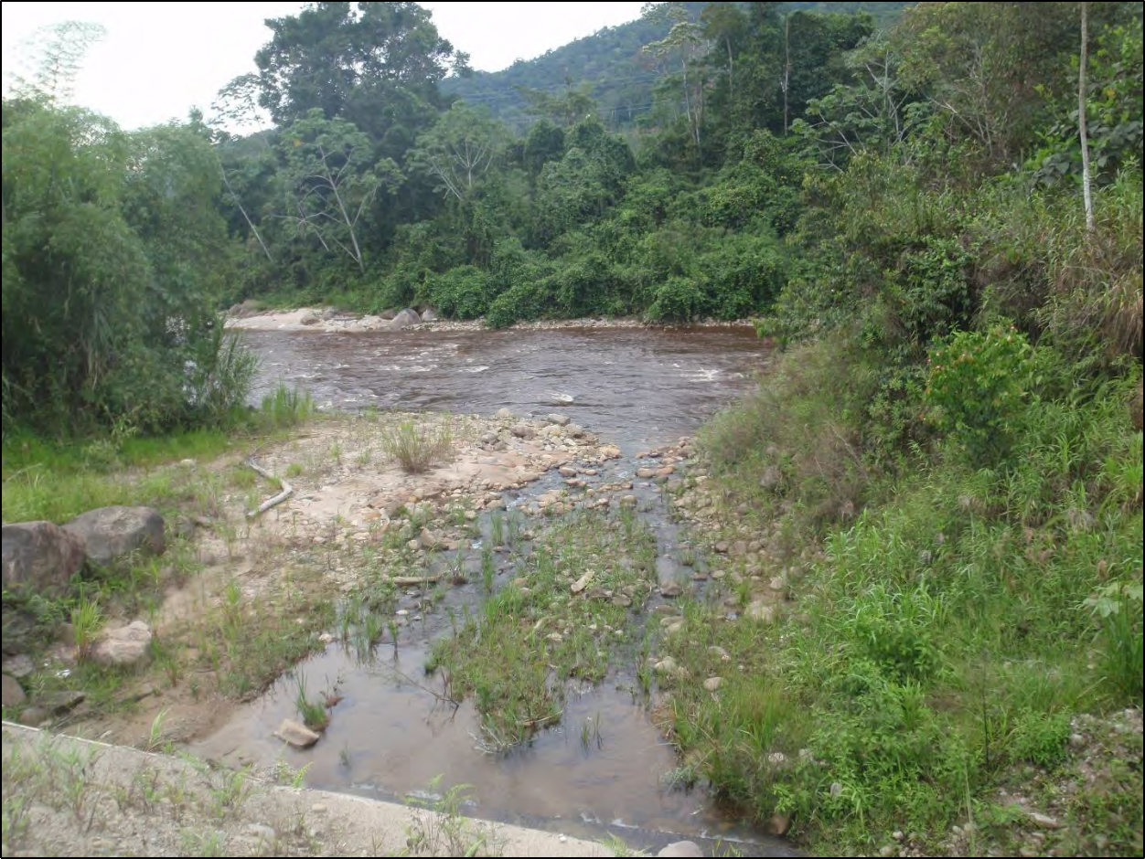
Figure 19b. The pipe from the sedimentation ponds discharges directly into the Rio Quimi. Photo taken by the author on November 6, 2018.

These changes in construction as a result of a shortage of construction material are a repetition of the sequence of events that led to the failure of the tailings dam at the Mount Polley mine. Failure to reevaluate the stability of the dam after the changes were made is also part of the sequence of events. According to the Independent Expert Engineering Investigation and Review Panel (2015), “It was planned to place the Zone C outslope to an ‘interim’ 1.4H:1V inclination— rather than the design basis 2.0H:1V—as a temporary expedient until mine waste delivery could catch up with construction…But instead of rectifying the interim steep slopes at this time as had been intended, such measures were left to future stages of embankment raising… Rather than adhering to a ‘centreline’ configuration, raise 2 utilized entirely ‘upstream’ construction…These as-built conditions were never reconciled with the Stage 2 stability analyses, which had been predicated on the original design configuration.”

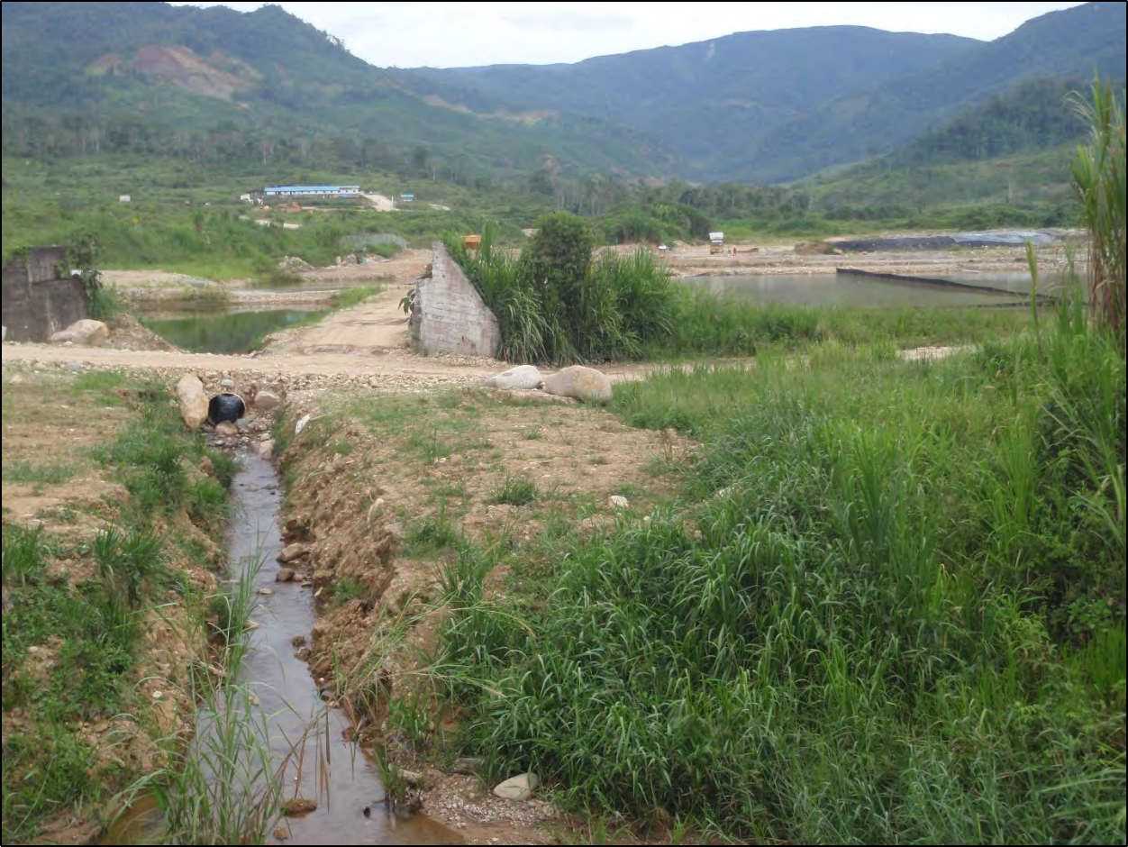
Figure 19c. The gray color of the discharge from the sedimentation pond demonstrates that the sedimentation ponds are not working (Quishpe Lozano et al., 2018). Photo taken by the author on November 6, 2018.

Probability of Failure of the Mirador Tailings Dams

It is now appropriate to consider rigorously the probability of failure of the Tundayme and Quimi dams. Knight-Pièsold (2007) determined that the probability of failure of the original design of the Quimi dam due to seismic liquefaction was 0.21% in any given year and 6.13% during the life of the project. (It should always be remembered that the risk of failure does not end after the project ends, but continues in perpetuity.) Emerman (2016) calculated that, if the original design of the Quimi dam would be used to build the Tundayme dam with changes only
in the heights of the dam and the tailings, the annual probability of failure would be 17.03 ×
0.21% = 3.59%, for a probability of failure during the 30 years of the life of the project of
66.56%. However, the following changes were made that increase the probability of failure of the Tundayme dam:
1) The design slope of the embankment was steepened from 1V:2H to 1V:1.5H.
2) The site was moved from the Quimi Valley (7% slope down to the Rio Quimi) to the
Tundayme Valley (13% slope down to the Rio Quimi).
3) The Tundayme tailings are in a larger watershed (with larger floods) and the design flood has changed from the Probable Maximum Flood to the 500-year flood.

4) There seems to be no commitment to build according to the design, especially no commitment to use the centerline construction method. It is important to note that the upstream construction method is more susceptible to all causes of dam failure.
Changes to the Quimi dam (change from centerline construction to upstream construction, steepening of the embankment slope from 1V:2H to 1V:1H) also increase the probability of failure of the Quimi dam. Based on the above, the probabilities of failure of both dams are so high that they should be regarded as inevitable.

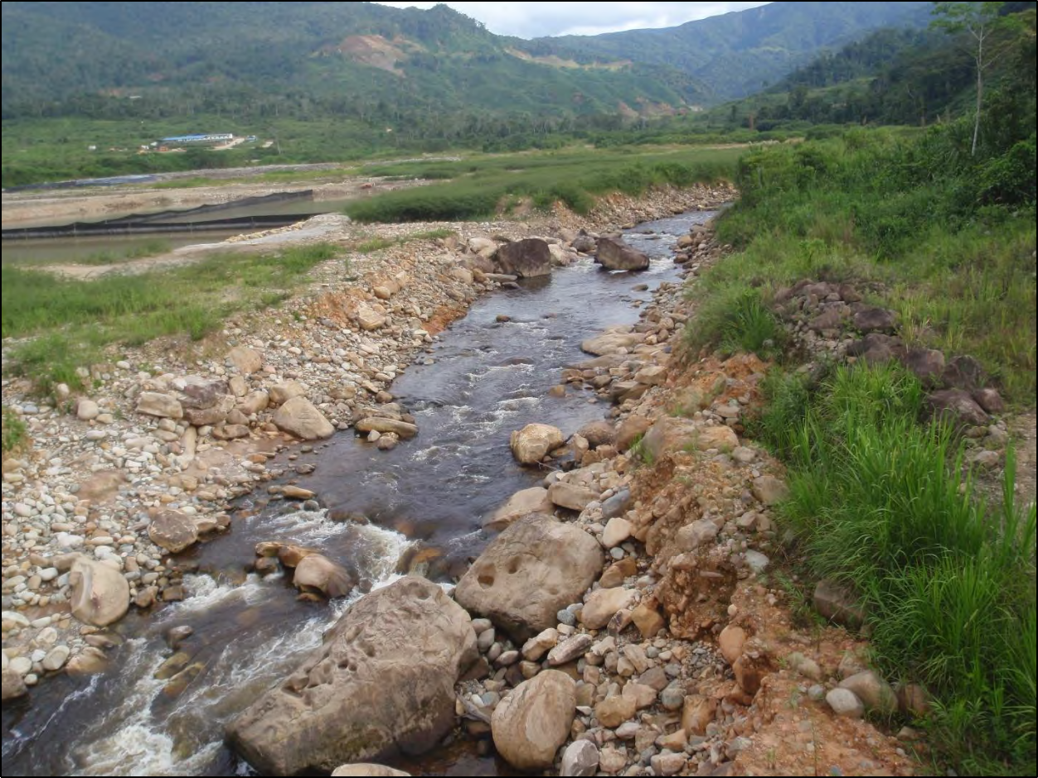
Figure 20. According to a complaint by the provincial government of Zamora Chinchipe (Quishpe Lozano et al.,
2018), “Here the extraction of rock material was carried out in a portion of the Rio Tundayme [shown above]. As in the Rio Quimi and the Rio Waywayme [see Figs. 2 and 11], the extraction of rock material in this area is not carried out within any mining concession for the exploitation of aggregates and rock…It should be noted that in the review conducted for the National Mining Registry, mining titles are not registered for the exploitation of rock material within the Mirador project in the aforementioned area.” A possible explanation for the illegal extraction of construction material from rivers is the lack of other sources of construction material. A shortage of construction material could also explain the change from centerline construction to upstream construction (see Fig. 16) and the excessively steep embankment of the starter dike (see Fig. 17). Photo taken by the author on November 6, 2018.

Consequences of Failure of the Tailings Dams

Finally, it is appropriate to reconsider the consequences of dam failure (see Fig. 2) based on the increase in height and storage volume of the dam. Larrauri and Lall (2018) published a

statistical model to predict the initial surge after the failure based on the history of tailings dam failures. According to this model, the best predictor of the initial surge is the dam factor Hf, defined as

𝐻𝑓 = 𝐻 (
𝑉𝐹
) 𝑉𝐹 (3)

𝑉𝑇

where H is the height of the dam (meters), VT is the total volume of confined tailings and water (millions of cubic meters), and VF is the volume of the spill (millions of cubic meters). The volume of the spill and the initial surge Dmax (kilometers) can be predicted as

𝑉𝐹 = 0.332 × �� 0.95
𝑇
(4)

��𝑚𝑎� = 3.04 × ��0.545
𝑓
(5)

Inserting H = 260 meters and VT = 390.097 million cubic meters (for the Tundayme dam; Cardno
(2014a)) in Eqs. (3) - (5) produces VF = 94 million cubic meters and a Dmax value of just under
350 kilometers. Although the predicted value of the initial surge may seem incredibly large, the calculation illustrates the difficulty of predicting the consequences of the Tundayme dam failure from the history of the consequences of tailings dam failures. The largest tailings spill in history was due to the failure of the Fundão dam in Brazil in 2015, which spilled 32 million cubic meters of water and tailings (Larrauri and Lall, 2018). With a height of 90 meters, the Fundão dam was also the tallest tailings dam that has ever failed (Larrauri and Lall, 2018). Even that dam with a
smaller H and VF than the Tundayme dam resulted in a measured Dmax of 657 kilometers
(Larrauri and Lall, 2018). The initial surge was clearly increased by the spill of tailings into a river, which would also occur in case of a failure of the Tundayme dam.
Based on the above calculation, the assignment of the risk category of VERY HIGH by Knight-Pièsold (2007) should also be reconsidered. The failure of the tailings dams at the Mirador mine would affect not only the mine and the downstream town of Tundayme, but a significant part of the headwaters of the Amazon River. Using the classification system of the Canadian Dam Association (2013), the only category of risk higher than VERY HIGH is EXTREME. This risk category includes the probable deaths of more than 100 people, the major loss of critical fish habitat and the impossibility of restoration or compensation in kind. To summarize this discussion, the failure of the tailings dams in the Mirador mine is inevitable and the consequences will be extreme.

CONCLUSIONS

The main conclusions of this report can be summarized as follows:
1) The design criteria of ability to resist a 500-year flood and a 500-year earthquake are inadequate for tailings dams for which failure would result in the loss of human lives and extensive environmental damage.
2) The assumption that coarser tailings will be non-sulfidic cannot be relied upon in the construction of tailings dams from the tailings themselves.

3) There has been no evaluation of the risks posed by landslides or the high rate of erosion in the area of the mining project.
4) Contrary to the design, the Quimi dam is being built using the upstream construction method, which is more susceptible to all causes of failures of tailings dams.
5) Contrary to the design, the Quimi dam has an embankment slope of 1V:1H, which is the maximum critical angle for preventing failure by internal erosion. From this point of view, the dam is susceptible to failure as soon as the tailings management facility is filled with wet tailings.
6) Contrary to the design, both alternatives of the Quimi dam and the Tundayme dam are currently under construction.
7) The failure of the tailings dams at the Mirador mine is inevitable and the consequences will be extreme.

RECOMMENDATIONS

The recommendation of this report is that there should be an immediate moratorium on further construction of the Mirador mine. The moratorium should be followed by the convening of an independent panel of international experts who will evaluate the design and construction of the Mirador tailings management facilities. This panel must be provided with full and complete information from EcuaCorriente S.A., without which it is impossible to make specific recommendations. This panel would be similar to the independent expert panels who evaluated the failures of the Mount Polley (Independent Expert Engineering Investigation and Review Panel, 2015) and Fundão tailings dams (Fundão Tailings Dam Review Panel, 2016). Unlike the previous expert panels, it is recommended that this panel be convened before the disaster and not after.

ACKNOWLEDEMENTS

I am grateful to Evelyne Blondeel of E-Tech International for her assistance during the mine site visit.

ABOUT THE AUTHOR

Dr. Steven H. Emerman has a B.S. in Mathematics from The Ohio State University, an M.A. in Geophysics from Princeton University, and a Ph.D. in Geophysics from Cornell University. Dr. Emerman has 31 years of experience in teaching hydrology and geophysics and has 66 peer-reviewed publications in these areas. Dr. Emerman is the owner of Malach Consulting, which specializes in assessing the environmental impacts of mining for mining companies, as well as for governmental and non-governmental agencies.

REFERENCES

AMEC Earth & Environmental, 2004. Preliminary Mine Closure and Reclamation Plan, Mirador
Project, Ecuador.
Canadian Dam Association, 2013. Dam safety guidelines 2007 (2013 edition), 88 p.

Campaña, J., L. Valenzuela, and A. Figueroa, 2015. The Quillayes sand tailings dam in Chile— design and operation: Proceedings Tailings and Mine Waste 2015 Vancouver, BC, 14 p. Available online at: https://open.library.ubc.ca/cIRcle/collections/59368/items/1.0320846
Cardno, 2014a. Actualización del Estudio de Impacto y Plan de Manejo Ambiental, para la Fase de Beneficio de Minerales Metálicos (cobre), Ampliación de 30 kt por día a 60 kt por día del Proyecto Minero Mirador, Concesión Minera “Mirador 1 (acumulada)” [Update of
the Environmental Impact Study and Environmental Management Plan, for the Beneficiation Phase of Metallic Minerals (copper), Extension from 30 kt per day to 60 kt per day of the Mirador Mining Project, Mining Concession “Mirador 1 (accumulated)”]: Report to EcuaCorriente S.A., 1206 p. with 6 appendices (1125 p.).
Cardno, 2014b. Actualización del Estudio de Impacto y Plan de Manejo Ambiental, para la Fase de Explotación a Cielo Abierto de Minerales Metálicos (cobre), Ampliación de 30 kt por día a 60 kt por día del Proyecto Minero Mirador, Concesión Minera “Mirador 1
(acumulada)” [Update of the Environmental Impact Study and Environmental Management Plan, for the Open-Pit Exploitation Phase of Metallic Minerals (copper), Extension from 30 kt per day to 60 kt per day of the Mirador Mining Project, Mining Concession “Mirador 1 (accumulated)”]: Report to EcuaCorriente S.A., 1130 p. with 6 appendices (1182 p.).
Connors, S.R., E.L. Hadley, M. Hansen, and S.H. Emerman, 2016. Reassessment of a tailings flow slide calculator: Geological Society of America Abstracts with Programs, v. 48, no. 7. Available online at: https://gsa.confex.com/gsa/2016AM/webprogram/Paper281555.html
Davies, M.P., 2002. Tailings impoundment failures—Are geotechnical engineers listening?: Geotechnical News, November 2002, pp. 31-36.
Emerman, S.H., 2014. Prediction of transport of mine tailings following failure of an earthen dam on the Rio Quimi, Ecuador: Report to E-Tech International, 7 p.
Emerman, S.H., 2015. Predicción de transporte de relaves mineros en la carga suspendida posterior a una falla de una represa de tierra para relaves en el Río Quimi en la mina Mirador, Ecuador [Prediction of transport of mine tailings in the suspended load after a failure of an earthen tailings dam in the Rio Quimi at the Mirador mine, Ecuador: Report to E-Tech International, 9 p. Available online at: https://static1.squarespace.com/static/52d71403e4b06286127a1d48/t/564a18c0e4b0f19ea e571949/1447696576435/Espanol-Emmerman-Mine-Tailing-Transport111515.pdf
Emerman, S.H., 2016. Effect of scaling on the safety of earthen dams—Application to a proposed expansion of the Mirador Mine, Ecuador: Report to E-Tech International, 11 p.
European Commission, 2009. Reference document on best available techniques for management of tailings and waste-rock in mining activities, 557 p. Available online at: http://eippcb.jrc.ec.europa.eu/reference/bref/mmr_adopted_0109.pdf
FEMA (Federal Emergency Management Agency), 2005. Federal guidelines for dam safety— Earthquake analyses and design of dams: FEMA-65, 75 p. Available online at: https://www.ferc.gov/industries/hydropower/safety/guidelines/fema-65.pdf
FEMA (Federal Emergency Management Agency), 2012. Summary of existing guidelines for hydrologic safety of dams: FEMA P-919, 474 p. Available online at: https://www.fema.gov/media-library-data/20130726-1849-25045-
1538/01_hydrosafetydam_intro.pdf

FEMA (Federal Emergency Management Agency), 2013. Selecting and accommodating inflow design floods for dams: FEMA-94, 38 p. Available online at: https://www.fema.gov/media-library-data/1386108128706-
02191a433d6a703f8dbdd68cde574a0a/Selecting_and_Accommodating_Inflow_Design_ Floods_for_Dams.PDF
Fisher, W.D., T.K. Camp, and V.K. Krzhizhanovskaya, 2017. Anomaly detection in earth dam and levee passive seismic data using support vector machines and automatic feature selection: Journal of Computational Science, v. 20, pp. 143-153.
Fourie, A.B., J.H. Palma, G. Villavicencio and R. Espinace, 2013. Risk minimisation in construction of upstream tailings storage facilities based on in-situ testing: Proceedings of the 18th International Conference on Soil Mechanics and Geotechnical Engineering,
Paris 2013, pp. 1471-1474.
Holtz, R.D., W.D. Kovacs, and T.C. Sheahan, 2011. An introduction to geotechnical engineering, 2nd ed.: Pearson, 863 p.
Imprensa Nacional [National Printer], 2019. Resolução Nº 4, de 15 de fevereiro de 2019 [Resolution No. 4 of February 15, 2019]. Available online at: http://www.in.gov.br/materia/-/asset_publisher/kujrw0tzc2mb/content/id/63799094/do1-
2019-02-18-resolucao-n-4-de-15-de-fevereiro-de-2019-63799056
Independent Expert Engineering Investigation and Review Panel, 2015. Report on Mount Polley
Tailings Storage Facility breach: Report to Ministry of Energy and Mines and Soda Creek Indian Band, 156 p. Available online at: https://www.mountpolleyreviewpanel.ca/sites/default/files/report/ReportonMountPolleyT ailingsStorageFacilityBreach.pdf
Jeyapalan, J.K., J.M. Duncan, and H.B. Seed, 1983. Analyses of flow failures of mine tailings dams: Journal of Geotechnical Engineering, v. 109(2), pp. 150-171.
Klohn Crippen Berger, 2017. Study of tailings management technologies: Report to Mine Environment Neutral Drainage (MEND) Program, MEND Report 2.50.1, 164 p. Available online at: http://mend-nedem.org/wp- content/uploads/2.50.1Tailings_Management_TechnologiesL.pdf
Knight-Pièsold, 2007. Rio Quimi Tailings Management Facility Feasibility Study for 27,000 tpd mine production. Ref. No. VA201-78/09-2, 111 p.
Kuipers, J., 2012. Evaluation of the stability of the Mirador Project Tailings Management Facility and an estimation of financial assurance requirements for the Mirador Copper Project, Ecuador: Report to E-Tech International, 20 p.
Larrauri, P.C. and U. Lall, 2018. Tailings dams failures—Updated statistical model for discharge volume and runout: Environments, v. 5. Available online at: doi:10.3390/environments5020028.
Fundão Tailings Dam Review Panel, 2016. Report on the immediate causes of the failure of the
Fundão Dam: Report to Cleary Gottlieb Steen & Hamilton, LLP, 88 p. Available online at: http://fundaoinvestigation.com/wp-content/uploads/general/PR/en/FinalReport.pdf
Le Poudre, D.C. (SNC Lavalin), 2015. Examples, statistics and failure modes of tailings dams and consequence of failure, Power Point Presentation, 42 slides. Available online at: https://www.esaa.org/wp-content/uploads/2015/10/15-LePoudre.pdf
NWS-HDSC (National Weather Service – Hydrometeorological Design Studies Center), 2017.
Current NWS Probable Maximum Precipitation (PMP) Documents. Available online at:
http://www.nws.noaa.gov/oh/hdsc/studies/pmp.html

Quishpe Lozano, S., E.G. Peña Otaneda, M.R. Vargas Santi, and M. Santi Gualinga, 2018.
Denuncia contra EcuaCorriente S.A. [Complaint against EcuaCorriente S.A.]: Fiscalía
General del Estado – Ecuador, Documento No. FGE-GD-2018-005305-EXT, 13 p. Skousen, J., J. Simmons, and P. Ziemkiewicz, 2001. The use of acid-base accounting to predict
post-mining drainage quality: Proceedings, America Society of Mining and Reclamation, pp. 437-447. Available online at: https://www.asmr.us/Portals/0/Documents/Conference- Proceedings/2001/0437-Skousen.pdf
TailPro Consulting, 2018. Conventional Impoundment Storage – The Current Techniques.
Available online at: http://tailings.info/disposal/conventional.htm
USACE (U.S. Army Corps of Engineers), 2000. Design and construction of levees: Manual No.
1110-2-1913, 164 p. Available online at:
https://www.publications.usace.army.mil/Portals/76/Publications/EngineerManuals/EM_
1110-2-1913.pdf
USACE-HEC (U.S. Army Corps of Engineers – Hydrologic Engineering Center), 2003.
Application of paleohydrology to Corps flood frequency analysis: RD-47, 34 p. Available online at: http://www.hec.usace.army.mil/publications/ResearchDocuments/RD-47.pdf
Vick, S.G., 1990. Planning, design, and analysis of tailings dams: BiTech Publishers, Vancouver, Canada, 369 p.
WMO (World Meteorological Organization), 2009. Manual on estimation of probable maximum precipitation: WMO-No. 1045, 257 p. Available online at: http://www.wmo.int/pages/prog/hwrp/publications/PMP/WMO%201045%20en.pdf
Walsh Scientists and Engineers, 2010a. Estudio de Impacto Ambiental para la Fase de Explotación a Cielo Abierto del Proyecto minero de cobre Mirador—Áreas mineras Mirador 1 - Mirador 2—Ecuacorriente S.A. (ECSA) [Environmental Impact Study for the Open-Pit Exploitation Phase of the Mirador Copper Mining Project—Mining areas Mirador 1 - Mirador 2 —Ecuacorriente S.A. (ECSA)]: Walsh Número de Proyecto
EC155-13, 748 p.
Walsh Scientists and Engineers, 2010b. Estudio de Impacto Ambiental para la Fase de Beneficio del Proyecto minero de cobre Mirador—Áreas mineras Mirador 1 - Mirador 2— Ecuacorriente S.A. (ECSA) [Environmental Impact Study for the Beneficiation Phase of the Mirador Copper Mining Project—Mining areas Mirador 1 - Mirador 2— Ecuacorriente S.A. (ECSA)]: Walsh Número de Proyecto EC155-14, 772 p.
Walsh Scientists and Engineers, 2011a. Plan de manejo Ambiental [Environmental Management
Plan]: Walsh Número de Proyecto EC155-14, 92 p.
Walsh Scientists and Engineers, 2011b. Respuesta observaciones del Estudio de Impacto Ambiental para la Fase de Beneficio del Proyecto minero de cobre Mirador [Response to Observations on the Environmental Impact Study for the Beneficiation Phase of the Mirador Copper Mining Project]: Walsh Número de Proyecto EC155-14, 110 p.
World Mine Tailings Failures, 2018. World Mine Tailings Failures—from 1915. Available online at: https://worldminetailingsfailures.org/

